"The Mother of Christ"
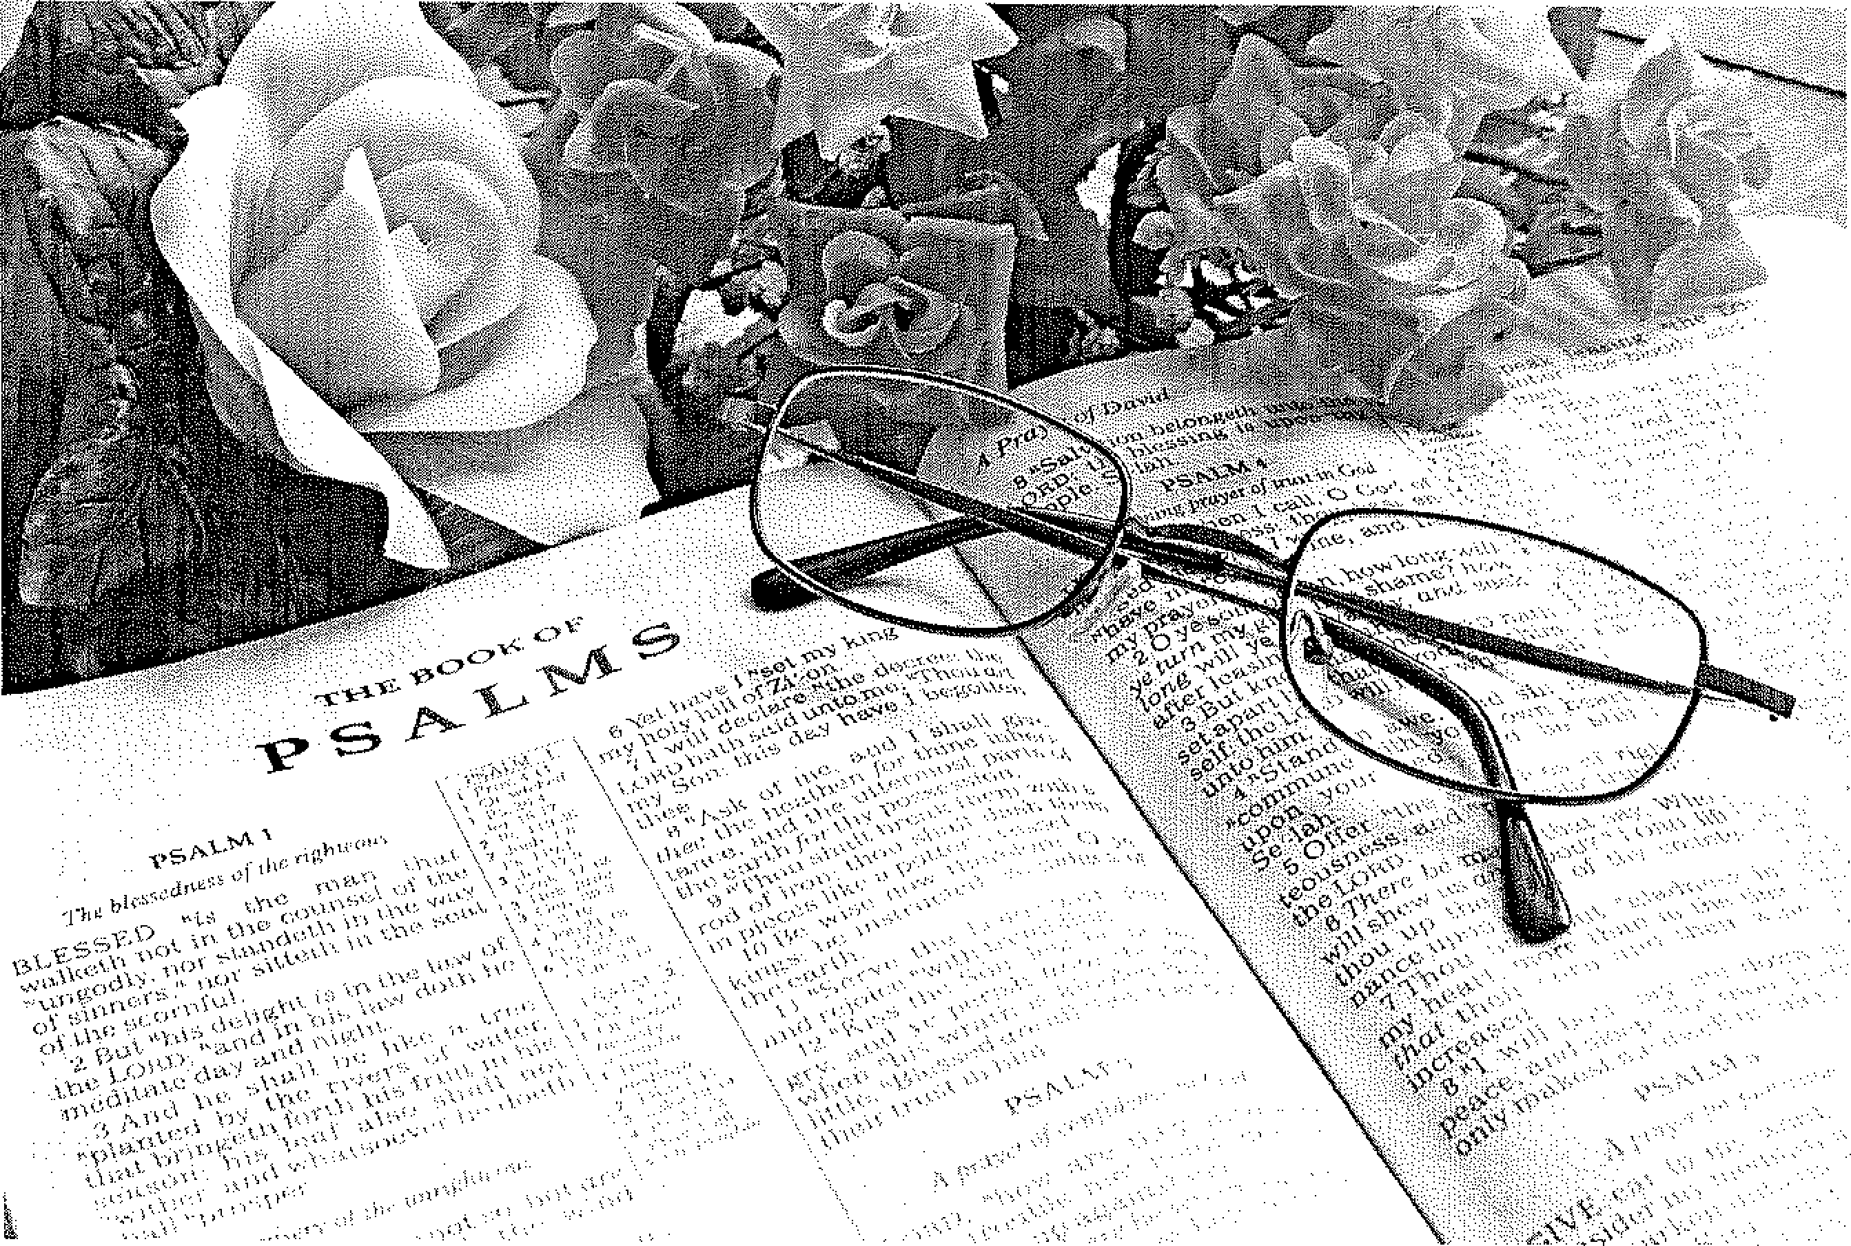
End of Year Programme for 2014
Womens Bible Study Clubs Mount Nasura

OPENING
2
PSALM 136:1&2
O give thanks and praise the LORD Praise the mighty King of Kings
God of gods with one accord, Who alone does wondrous things
For His steadfast love is sure For His steadfast love is sure
It shall evermore endure. It shall evermore endure.
EVE
Meditation:
The LORD God in the beginning created everything perfectly, also the mysterious way of Eve from the rib of Adam, and the LORD brought her to Adam.
Then God blessed them, and God said to them, "Be fruitful and multiply; fill the earth and subdue it, have dominion over the fish of the sea over the birds of the air, and over every living thing that moves on the earth." And God said, "See, I have given you every herb that yields seed which is on the face of all the earth, and every tree whose fruit yields seed; to you it shall be for food. (Gen 1:28+29)
In a wonderful covenant relationship with their Creator they could live perfectly and enjoy each other's company.
Eve, whom God made Adam's helpmeet to serve Him, became disobedient by listening to the serpent; Satan the deceiver.
She took the lead and ate of the one fruit that was forbidden and also gave some to Adam, while both of them knew that the Lord had expressly forbidden them to eat of that tree. Yes they both ate and now they realized that the wonderful relationship with God had been
broken, and also the relationship between themselves was broken by their disobedience; as we confess in LD 4; Man, at the instigation of the devil, in deliberate disobedience robbed himself and all his descendants of these gifts. Therefore God will punish them by a just judgment both now and eternally.
Satan wanted to destroy God's wonderful creation, he seemed victorious, but our graceful God prepared a wonderful way of escape. God would not destroy the world by His divine judgment, but would glorify Himself by delivering His creation.
He came to Adam and Eve when they hid themselves in the garden because of guilt. He came to them in His unspeakable love.
He promised that the seed of the woman would crush the head of the serpent.
Let us live our lives in thankful obedience to Him for this rich gift.
Remembering I Tim 2:14+15 "And Adam was not deceived, but the woman being deceived fell into transgression. Nevertheless she will be saved in childbearing if they continue in faith, love, and holiness, with self-control.

SINGING Psalm: 33:1+2

Rejoice before the Lord, you righteous; and with a new song praise his name.
Praise is most fitting for the upright; with harp and lyre declare His fame. For the LORD has spoken
words of truth unbroken;
He is faithful still.
Righteousness He treasures;
earth is with the measures
of His goodness filled.
By his command he made the heavens; their starry host by His decree.
He gathered in His storehouse chambers the waters of the deepest sea.
Let the earth revere Him; and its peoples fear Him. God spoke; and 't was done. He set all creation
firm on its foundation. Praise Him, everyone!

SARAH
3
Meditation:
The Lord had long ago promised Abraham and Sarah a son (Gen 17). They had embraced that promise eagerly when God first announced it years ago. Sarah knows that she is now past her child- bearing years. And yet the LORD had promised that the Messiah would be a descendant of her son. That promise does not depend on the biological condition of Sarah; it depends on God's word. God will do what He promised; even though the situation seems to be impossible.
Sarah laughs. It is laughter of unbelief. She did not accept God's Word for truth. Yet is anything too hard for the Lord? (Gen 18:14) God knew very well that Sarah was old; well advanced in age; past the age of childbearing. But don't we see what a great miracle God has performed here in His faithfulness and goodness? ,
After the long - long wait; the course of God's revelation through history breaks way through the birth of the Seed; not of Ishmael; but of Isaac; and the historical perspective is opened for the Seed, Jesus Christ; through whom the promised salvation of the world would come.
Yes Sarah laughs; yet later (Gen. 21:6) when Isaac was born; Sarah laughed for joy at the supernatural work of Grace. "God has made laughter for me; everyone who hears will laugh over me. With this laughter God was pleased. Isaac is called the child of the promise in scripture (Gal 4:28). Why?
"Because by faith Sarah herself received strength to conceive seed; and she bore a child when she was past the age; because she judged Him faithful Who had promised." (Heb 11: 11)
We who have received the promise of salvation; are the spiritual seed of Abraham through
faith; and like Isaac; children of the promise; in whom the Word of God's promise works our eternal salvation.

SINGING PS 105:1+2
4
O thank the LORD with great rejoicing, his deeds among the peoples voicing! Praise Him, His wondrous works proclaim and glory in His holy Name.  Let those who seek Him praise the LORD, their hearts exulting in His word. | Turn to the LORD, who fails us never, and seek His face, His strength, forever. Recall the wonders He has wrought, the righteous judgments He has taught. Remember these, you chosen ones,  O Abra’m’s offspring, Jacob’s sons!

REBEKAH
Meditation:
The Lord God continues His care, and fulfils His promises.
He directs Eliezer, Abraham's servant, to find a wife for Isaac in a miraculous way. Abraham the father of Isaac cares also for Isaac's seed and speaks of his trust in the Lord's guidance in Gen 24:7;
"The LORD God of heaven, who took me from my father's house and from the land of my family, and who spoke to me and swore to me, saying, "To your descendants I give this land”, He will send His angel before you, and you shall take a wife for my son from there. And if the woman is not willing to follow you, then you will be released from this oath; only do not take my son back there."
Rebekah is willing to leave the very next day. Here we see God's fatherly guidance in —her willingness.
She receives a rich blessing from her family (Gen 24:60) They blessed Rebekah and said to her: "Our sister, may you become the mother of thousands of ten thousands;
And may your descendants possess the gates of those who hate them."
Amazingly that nearly the same words were spoken by the Lord to Abraham on Mount Moriah. (Gen 22:17)
In the way of obedience and faith the LORD preserved Abraham's seed. Christ Himself prepared His coming into the World. He was on guard and ensured that Satan did not obtain the victory.
This story is not just a love story. No, it is full of God's faithfulness and guidance. Abraham was placed on the Messianic road by God. Isaac had to continue on that road.
The vacancy of "the mother of the church" created by Sarah's death has now been filled. The LORD is going to fulfill His promises to Abraham, a new generation presents itself. Isaac and Rebecca.
Rebecca is, through her faith also a true daughter of Abraham.
In this way God fulfils His promise to him.

SINGING Ps 105:3+4
5
He is the LORD, our God unfailing,  his judgments everywhere prevailing. He will remember and upheld  his cov’nant made in days of old. The steadfast words He did command a thousand generations stand. | Firm stands His word to Abra’m spoken  his oath to Isaac, never broken. His everlasting covenant  with Israel God will not recant.  He promised Is’rel, “You I”ll give,  the land where you as heirs may live.”

RAHAB
Meditation:
By faith the prostitute Rahab did not perish with those who did not believe, when she received the spies with peace (Heb. 11:31)
The LORD led the two spies to Rahab's house. The Bible calls her a prostitute; she sold her body for money. It is not without reason that we are told, what she was. *This visit became one of critical importance for Rahab. It was the great turnabout of her life.
The spies had been seen entering her house. Yet she misled the king's soldiers. Why'? Because she had chosen the side of the God of Israel. James 2:25 tells us." Likewise, was not Rahab the prostitute also justified by works when she received the messengers and sent them out another way?"
God's word reveals the LORD's sovereign good pleasure by working faith in Rahab's heart. She acknowledges His almighty hand by saying: (Joshua 2:9-13) "I know that the LORD has given you the land, that the terror of you has fallen on us, and that all the inhabitants of the land are fainthearted because of you. For we have heard how the LORD dried up the water of the Red Sea for you when you came out of Egypt, and what you did to the two kings of the Amorites who were on the other side of the Jordan, Sihon and Og, whom you utterly destroyed. And as soon as we heard these things, our hearts melted; neither did there remain any more courage in anyone because of you, for the LORD your God, He is God in heaven above and on earth beneath. Now therefore, I beg you, swear to me by the LORD, since I have shown you kindness that you also will show kindness to my father's house, and give me a true token, and spare my father, my mother, my brothers, my sisters, and all that they have, and deliver our lives from death"
The spies had not seen much of the city, yet the main item in their report was that the awesome message of the Lord had already gone before them. God had put a paralyzing fear into the people's hearts.
The spies could not say much about the defense works. They could only repeat the most important fact: "The LORD has given the whole land into our hands."' They didn't trust in their power and resources, but looked to the LORD.
Again we may observe the LORD's mighty and gracious acts. He used Rahab for the benefit of the church.
In Matthew 1:5 Rahab is mentioned as the mother of Boaz, she is one of the ancestral mothers of David and also of our Lord Jesus Christ.

SINGING: PS 87:1,2+5
1. Our gracious God has laid secure foundations  And built his city on Mount Zion's heights.  He loves her gates and he in them delights more than in all the towns of Jacob's nation. | 2. What glorious things, O city of God's favour, Are said of you, proclaimed in joyful tone:  “I number Egypt, even Babylon,  Among all those who know Me as their Saviour.

5. This will the LORD write in the roll of nations:
These, born in Zion, all to me belong.”
With joyful music they proclaim in song:
"In Zion are the springs of my salvation."
NAOMI AND RUTH
Meditation:
Elimelech took a dead end road. For it was not the way of obedience to the LORD, to leave the land of Israel, but a way of calculations and good intentions. This, while a child of the LORD may only expect blessings in the way of obedience. Elimelech and Naomi have left the covenant. However, the Lord has not left Naomi. He forces her to think of returning. After Elimelech and his sons had died in Moab. The LORD has not let go of Naomi. He wants to bring her back to the land of promise, back in the covenant, to the church. In His grace He has not severed the bond, but has taken it up into His plan of salvation. We can deduce from Ruth's words and her perseverance that Naomi has instructed her daughters-in-law about loving Jaweh, and keeping the covenant. Yet while travelling to the promised land, Naomi pleads with her daughters to go back to their own people where there will be a future for them. Naomi still has to learn to trust the Lord in everything. Orpah leaves, but Ruth does not allow herself to be convinced by Naomi. She understood in faith all that Naomi had told them about the LORD of the covenant and his service. This comes out in her beautiful confession, which we find in Ruth 1:16+17.
"Entreat me not to leave you, or to turn back from following you; For wherever you go, I will go; and wherever you lodge, I will lodge; Your people shall be my people, and your God my God.
And where you die, I will die, and there will I be buried.
The LORD do so to me, and more also, if anything but death parts you and me."
It is a miracle that despite everything Ruth says to Naomi, "and yet I will stay with you" This is the work of the Holy Spirit. , Ruth the Moabitess, a descendant of one of the daughters of Lot, belonged to a people who were often at war with Israel. But this Moabitess was chosen by the LORD to be a mother in the linage of our Lord Jesus Christ. This story is not about people. It is not a story of love preceded by sorrow but with a happy ending. It is all about the LORD Who works by means of sinful people to the coming of the great Redeemer. God uses people like us to fulfill His plan. He is the Almighty One Who attains His goal. Nothing can hinder the realization of that aim. Not the sins of man or Satan.
We are allowed to see that the LORD works in such a way that He exceeds all of man's expectations. He is faithful in keeping His promises. Sovereignly He works on carrying out His plan. Right through the midst of the sins of people God weaves His plan of salvation. He turns the bad into good. He is merciful and gracious: He works towards the coming of the Messiah. He wanted to use Ruth for this.
How wonderful are the ways of the LORD!

SINGING Hymn 17:1,3+6
7
1. My soul does magnify the LORD for He Most High has shown to me His favour, I praise Him with my voice; my spirit does rejoice  in Him, my God and Saviour. | 3. How holy is His Name  the Mighty One, He came  and showed me his great favour. With mercy he is near  to all who him revere;  his love endures forever.

6. The LORD is merciful,
his servant Israel,
He graciously delivered,
rememb’ring evermore
what he to Abra’m swore
And to his seed forever.
MARY
Meditation:
The angel Gabriel was sent to earth, to Galilee. Galilee was of little importance, the small despised town of Nazareth lay between the low hills. Here the angel entered a house of an unmarried girl named Mary. She lived close to the LORD and was engaged to a young man, also of the house of David like herself. This seemingly had no significance to Mary. She was poor and lived in a despised little town, in the land oppressed by Herod the Edomite. The land was absorbed into the powerful empire of Caesar Augustus. Mary was greatly troubled when the angel greeted her, "Rejoice, highly favoured one, the LORD is with you,"
The angel did not leave her pondering too long over his coming. He told her not to be afraid, for - "you have found favour with God you shall become mother of a son and you shall call his name Jesus. He will be great and will be called the Son of the Most High and the LORD God will give Him the throne of His father David and He will reign over the house of Jacob forever, and of His kingdom there shall be no end. Mary found it hard to comprehend this wonderful message, but the angel explained to her "The Holy Spirit will come upon you and the power of the highest will overshadow you: therefore the Child who is to be born will be the Son of God."
The angel continued his encouragement by telling her about Elizabeth, her cousin, who was also expecting after years of barrenness, and concludes with the message "For with God nothing is impossible."
This great word from God's angel was enough for her. God’s promise would come true. She desired nothing more than that. She bowed her head and in complete submission said: "I am the Lord's servant: let it be to me as you have said."
So Christ our Saviour was born.
And we as women of the New Testament time. The time of waiting list His glorious return.
May work toward His coming by being faithful in obedience to Him and His Word, in all we do and say.

SINGING: Hymn 2

1. In God, our heavenly Father I believe, Almighty Ruler, all victorious,
Creator of both heaven and earth, whose holy Name is great and glorious. And I believe in Christ our Lord —Christ Jesus the incarnate Word,
God's only Son, our faithful Saviour, sent to redeem a world forlorn:
who was conceived by God the Spirit and of the virgin Mary born.
2. Our Lord was under Pilate crucified; the burden of God's wrath He carried. Rejected and despised by men,
He died for us, and then was buried, descending into death's domain. But He the third day rose again:
He to His heavenly throne ascended, at God's right hand, and He, our Head, shall come again with power and glory to judge the living and the dead.

3. In God the Holy Spirit I believe —
through whom we are a new creation.
And I believe a cath’lic Church
A holy Christian congregation:
the true communion of all those
whom God once as His people chose;
the full forgiveness of transgressions,
release from sin and mortal strife
the resurrection of the body,
and glorious, everlasting life.
SINGING: Hymn 67:1,2+7

- “Come Lord Jesus! Maranatha!” pray the Spirit and the Bride.
Come upon the clouds of heaven With your angels at your side. Maranatha! Come, Lord Jesus! Evermore with us abide.
2. Come, O Lord, with pow’r and glory and descend before our eyes
when the sounding of the trumpet shall re-echo through the skies and the voice of your archangel shall command the dead to rise.

7. No one knows the day or moment when the Bridegroom shall appear. Let us then be ever watchful;
may our lamps be bright and clear. Maranatha! Come, Lord Jesus!
Your great Day is drawing near.

