The Jesse Tree
The Jesse Tree

Christmas Meeting Mount Nasura 2018

There shall come forth a Rod from the
stem of Jesse, and a Branch shall grow
out of his roots.
Isaiah 11:1

SING: Hymn 20: 1-4

1. A great and mighty wonder 2. The Word became incarnate –
upon the earth was done made flesh, yet very God.
when Mary, virgin mother, The angels hailed His coming
gave birth to God’s own Son. with songs o’er fields abroad.
Repeat the song again: Repeat the song again:
“To God on high the glory, “To God on high the glory,
and peace on earth to men!” and peace on earth to men!”

3. Sing praise to God the Father; 4. Since He came us to ransom,
join with the heavenly bands. let Him now be adored,
Rejoice, O vales and mountains, the King once born in Bethlehem,
and, oceans, clap your hands! our Saviour and our Lord.
Repeat the song again: Repeat the song again:
“To God on high the glory, “To God on high the glory,
and peace on earth to men!” and peace on earth to men!”

PRAYER

WELCOME

SING: Angels from the realms of glory (vs 1)

Angels from the realms of glory
wing your flight o'er all the earth.
Ye, who sang creation's story
now proclaim Messiah's birth.
Come and worship, come and worship,
worship Christ the newborn King.

1. CREATION OF THE WORLD

Our natural starting point is God’s marvelous, miraculous work of creation, for which He deserves all glory.
After creating After creating all things in six days, God finished with the crowning glory, the creation of man, the first Adam. We
read from Genesis 1:26-31:

Then God said, “Let Us make man in Our image, according to Our likeness; let them have dominion over the fish of the sea, over the birds of the air, and over the cattle, over all the earth and over every creeping thing that creeps on the earth.” So God created man in His own image; in the image of God He created him; male and female He created them. Then God blessed them, and God said to them, “Be fruitful and multiply; fill the earth and subdue it; have dominion over the fish of the sea, over the birds of the air, and over every living thing that moves on the earth.”
And God said, “See, I have given you every herb that yields seed which is on the face of all the earth, and every tree whose fruit yields seed; to you it shall be for food. Also, to every beast of the earth, to every bird of the air, and to everything that creeps on the earth, in which there is life, I have given every green herb for food”; and it was so. Then God saw everything that He had made, and indeed it was very good. So the evening and the morning were the sixth day.

2. ADAM AND EVE

Imagine the sorrow God felt watching the temptation of the serpent, and the falling into sin of Adam and Eve. He could have prevented it but He chose to give Adam and Eve free will – He wanted willing obedience from them. And when they failed they deserved death. Our comfort is that even this act of disobedience was not unforeseen by God, and He came to Adam and Eve immediately after the fall into sin with gracious love, and the amazing promise of a Saviour. That is a message of hope for us.

We read in Genesis 3:14-15:

So the LORD God said to the serpent:
“Because you have done this, you are cursed more than all cattle, and more than every beast of the field; on your belly you shall go, and you shall eat dust all the days of your life. And I will put enmity between you and the woman, and between your seed and her Seed; He shall bruise your head, and you shall bruise His heel.”

3. NOAH

In the flood we see God’s justice and His anger at sin, but we also see His faithfulness to His promise – all men were not destroyed, but a remnant was kept from death. God promised that a Saviour would come to crush Satan, and so, through Noah, that promise would still come true. After the flood God continued to show His faithfulness and mercy by making a covenant with Noah, and through him, with all of mankind.

We read in Genesis 6:11-14:

The earth also was corrupt before God, and the earth was filled with violence. So God looked upon the earth, and indeed it was corrupt; for all flesh had corrupted their way on the earth.
And God said to Noah, “The end of all flesh has come before Me, for the earth is filled with violence through them; and behold, I will destroy them with the earth. Make yourself an ark of gopherwood; make rooms in the ark, and cover it inside and outside with pitch.”
And further in Genesis 9:8-13:

Then God spoke to Noah and to his sons with him, saying: “And as for Me, behold, I establish My covenant with you and with your descendants after you, and with every living creature that is with you: the birds, the cattle, and every beast of the earth with you, of all that go out of the ark, every beast of the earth. Thus I establish My covenant with you: Never again shall all flesh be cut off by the waters of the flood; never again shall there be a flood to destroy the earth.”
And God said: “This is the sign of the covenant which I make between Me and you, and every living creature that is with you, for perpetual generations: I set My rainbow in the cloud, and it shall be for the sign of the covenant between Me and the earth.”

SING: Hymn 80: 2, 3, 4

2. Give to the Lord of lords renown;
the King of kings with glory crown.
His mercies ever shall endure,
when lords and kings are known no more.

3. He built the earth, He spread the sky,
and fixed the starry lights on high.
Wonders of grace to God belong;
repeat His mercies in your song.

4. He fills the sun with morning light;
He bids the moon direct the night.
His mercies ever shall endure,
when sun and moon shall shine no more.

4. ABRAHAM

In the first 11 chapters of Genesis we are continually confronted with the sin of mankind and the judgement of God. We read of the fall into sin of Adam and Eve, the murderous sin of Cain, the wickedness of man that led to the flood. Even after the flood, the story of the tower of Babel shows that the heart of man still puts himself in the centre, disregarding God. Thanks be to God that chapter 12 of Genesis begins the story of salvation history, ultimately centered in Christ. God builds a community of covenant people beginning with Abraham, and through him, all the families on earth will receive blessing. While the world is in confusion, God is quietly, secretly, undramatically working out His purpose. God’s plan for all the families of the earth is linked to His blessing of one man, and onwards through the generations to David. We look even further through David’s family tree to one called Joseph who was betrothed to Mary, who gave birth to her first born son in Bethlehem in the days of Caesar Augustus.

The purposes of the tests and trials suffered by Abraham, Isaac, Jacob and Joseph may not always have been clear to them, but God required simple faith, from them and from us. And that means just this: God speaks, man believes. Faith is trust that relies on God without having His reasons unfolded to us. God’s promises to be their God were their certainty, their source of peace and security. We who live in the New Testament are blessed to see that God’s promises all came true.

We read in Genesis 12:1-7:

Now the LORD had said to Abram:
“Get out of your country, from your family and from your father’s house, to a land that I will show you. I will make you a great nation; I will bless you and make your name great; and you shall be a blessing. I will bless those who bless you, and I will curse him who curses you; and in you all the families of the earth shall be blessed.”

And further in Genesis 15:1-6:

After these things the word of the LORD came to Abram in a vision, saying, “Do not be afraid, Abram. I am your shield, your exceedingly great reward.”
But Abram said, “Lord God, what will You give me, seeing I go childless, and the heir of my house is Eliezer of Damascus?” Then Abram said, “Look, You have given me no offspring; indeed one born in my house is my heir!”
And behold, the word of the LORD came to him, saying, “This one shall not be your heir, but one who will come from your own body shall be your heir.” Then He brought him outside and said, “Look now toward heaven, and count the stars if you are able to number them.” And He said to him, “So shall your descendants be.”
And he believed in the LORD, and He accounted it to him for righteousness.

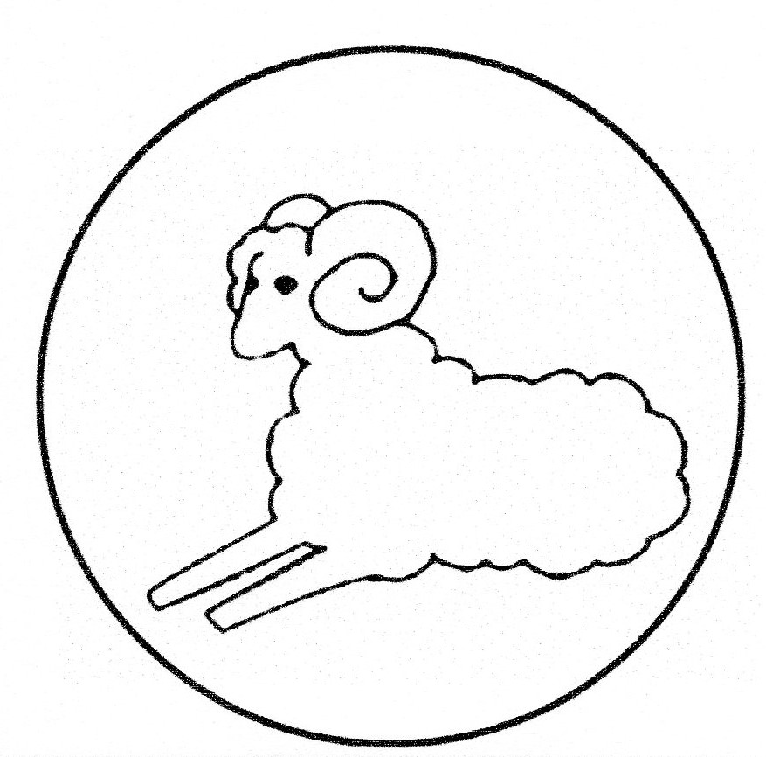
5. ISAAC

Genesis 22:9-18

Then (Abraham and Isaac) came to the place of which God had told him. And Abraham built an altar there and placed the wood in order; and he bound Isaac his son and laid him on the altar, upon the wood. And Abraham stretched out his hand and took the knife to slay his son.
But the Angel of the LORD called to him from heaven and said, “Abraham, Abraham!” So he said, “Here I am.”
And He said, “Do not lay your hand on the lad, or do anything to him; for now I know that you fear God, since you have not withheld your son, your only son, from Me.”
Then Abraham lifted his eyes and looked, and there behind him was a ram caught in a thicket by its horns. So Abraham went and took the ram, and offered it up for a burnt offering instead of his son. And Abraham called the name of the place, The-LORD-Will-Provide; as it is said to this day, “In the Mount of the LORD it shall be provided.”
Then the Angel of the LORD called to Abraham a second time out of heaven, and said: “By Myself I have sworn, says the LORD, because you have done this thing, and have not withheld your son, your only son - blessing I will bless you, and multiplying I will multiply your descendants as the stars of the heaven and as the sand which is on the seashore; and your descendants shall possess the gate of their enemies. In your seed all the nations of the earth shall be blessed, because you have obeyed My voice.”

SING: Psalm 105: 3, 4

3. He is the LORD, our God unfailing,
his judgments everywhere prevailing.
He will remember and uphold
his covenant made in days of old.
The steadfast words of his command
a thousand generations stand.

4. Firm stands his word to Abraham spoken,
his oath to Isaac, never broken.
His everlasting covenant
the LORD our God will not recant.
He promised Israel, “You I’ll give
the land where you as heirs may live.”

6. JACOB
Genesis 28:10-15

Now Jacob went out from Beersheba and went toward Haran. So he came to a certain place and stayed there all night, because the sun had set. And he took one of the stones of that place and put it at his head, and he lay down in that place to sleep. Then he dreamed, and behold, a ladder was set up on the earth, and its top reached to heaven; and there the angels of God were ascending and descending on it.
And behold, the LORD stood above it and said: “I am the LORD God of Abraham your father and the God of Isaac; the land on which you lie I will give to you and your descendants. Also your descendants shall be as the dust of the earth; you shall spread abroad to the west and the east, to the north and the south; and in you and in your seed all the families of the earth shall be blessed. Behold, I am with you and will keep you wherever you go, and will bring you back to this land; for I will not leave you until I have done what I have spoken to you.”

7. JOSEPH

We read the words of Joseph in Genesis 45:4-8:

And Joseph said to his brothers, “Please come near to me.” So they came near. Then he said: “I am Joseph your brother, whom you sold into Egypt. But now, do not therefore be grieved or angry with yourselves because you sold me here; for God sent me before you to preserve life. For these two years the famine has been in the land, and there are still five years in which there will be neither plowing nor harvesting. And God sent me before you to preserve a posterity for you in the earth, and to save your lives by a great deliverance. So now it was not you who sent me here, but God; and He has made me a father to Pharaoh, and lord of all his house, and a ruler throughout all the land of Egypt.”
Joseph sent a message to his father, Jacob, to move his family and possessions to Egypt, and Jacob did so, first seeking counsel from the LORD. We read in Genesis 46:1-3:

So Israel took his journey with all that he had, and came to Beersheba, and offered sacrifices to the God of his father Isaac. Then God spoke to Israel in the visions of the night, and said, “Jacob, Jacob!”
And he said, “Here I am.”
So He said, “I am God, the God of your father; do not fear to go down to Egypt, for I will make of you a great nation there. I will go down with you to Egypt, and I will also surely bring you up again; and Joseph will put his hand on your eyes.”

SING: Psalm 105: 6, 7

6. Where Jacob dwelt among the nations,
God summoned famine and starvation,
destroying every source of bread.
But he had sent a man ahead,
that he his chosen ones might save.
This man was Joseph, sold as slave.

7. In Egypt he endured great anguish;
in prison he was left to languish.
His feet were bruised, with shackles chained;
his neck in irons long remained.
But when the LORD’s word proved him right,
he was delivered from this plight.

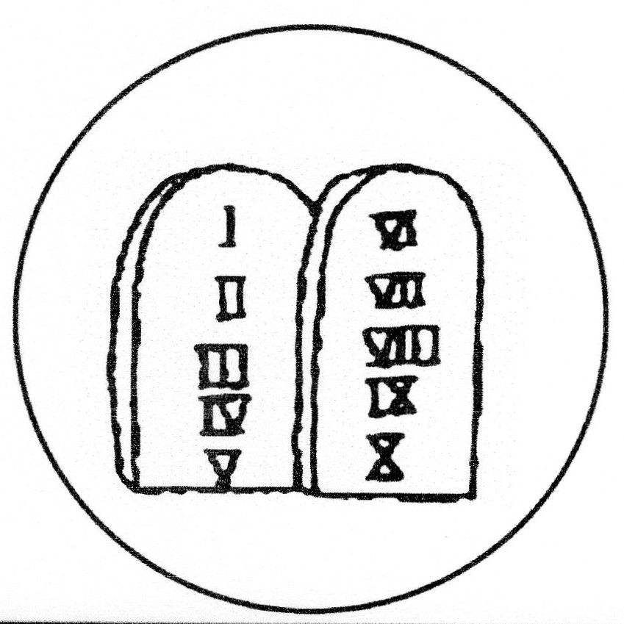
8. MOSES
The wonderful promises of God to the patriarchs were passed on down through the generations - the fathers sitting at the table telling their children the stories of their ancestors, teaching them about the God of Abraham, Isaac and Jacob. They would have told their children about the great man, Joseph, Jacob’s son, who was second in charge of Egypt so many years ago. Even Joseph had said in Genesis 50 that God would bring them out of Egypt to the land of promise. Egypt would not be their final destination.

But here we have the nation of Israel in Egypt, and how much further can they be from seeing the fulfilment of these promises? They are in a foreign country. They are slaves, brutally oppressed. Where was God? His name is not even mentioned in Exodus 1, and that’s probably what it felt like to Israel. Where is this God? He seems to be absent. Surely He’s forgotten us. Does He really care?

But it was not an accident that Israel was in Egypt. In Genesis 15:13 and 14 we read what God said to Abraham:
Know certainly that your descendants will be strangers in a land that is not theirs, and will serve them, and they will afflict them four hundred years. And also the nation whom they serve I will judge; afterward they shall come out with great possessions.

We can see God’s hand at work from beginning to end. We see Him working out His own schemes in His own way, on His own scale, to His own time plan and according to His own wisdom, and we find the assurance that, although the days were dark, it was all right, it was all planned and it will all be well.

While to the Israelites, it may have seemed as if God was absent, God never for one second forgot about them. At the right time He raised up His servant Moses, a reluctant servant who saw his own weaknesses more than God’s strength, but who was empowered by God to be the leader of His people Israel.

We read in Acts 7 the address of Stephen to the Jews. He tells of Moses’ experience at the burning bush, and then we read from vs 35-37:

“This Moses whom they rejected, saying, ‘Who made you a ruler and a judge?’ is the one God sent to be a ruler and a deliverer by the hand of the Angel who appeared to him in the bush. He brought them out, after He had shown wonders and signs in the land of Egypt, and in the Red Sea, and in the wilderness forty years.
“This is that Moses who said to the children of Israel, ‘The LORD your God will raise up for you a Prophet like me from your brethren. Him you shall hear.’

God used Moses to deliver His people from Egypt, and brought His people to the land of Canaan. But through this the Holy Spirit points us to the One who was coming, who would redeem His people from slavery to sin, and bring us to the eternal land of promise, our heavenly home.

And God gave the Israelites a sign: the Passover pointed to the coming of Christ, the Lamb who would be killed for the sins of the people. True redemption was coming.

SING: Hymn 12:14

O come and with His people now rejoice:
shout forth your praises, all you nations!
To thank the LORD lift up your voice
and sing your songs of jubilation.
The LORD is good, his mercy great:
his servants he will vindicate,
wreak vengeance on his adversaries.
His chosen people he has shown
the covenant love that never varies
and for their land will he atone.

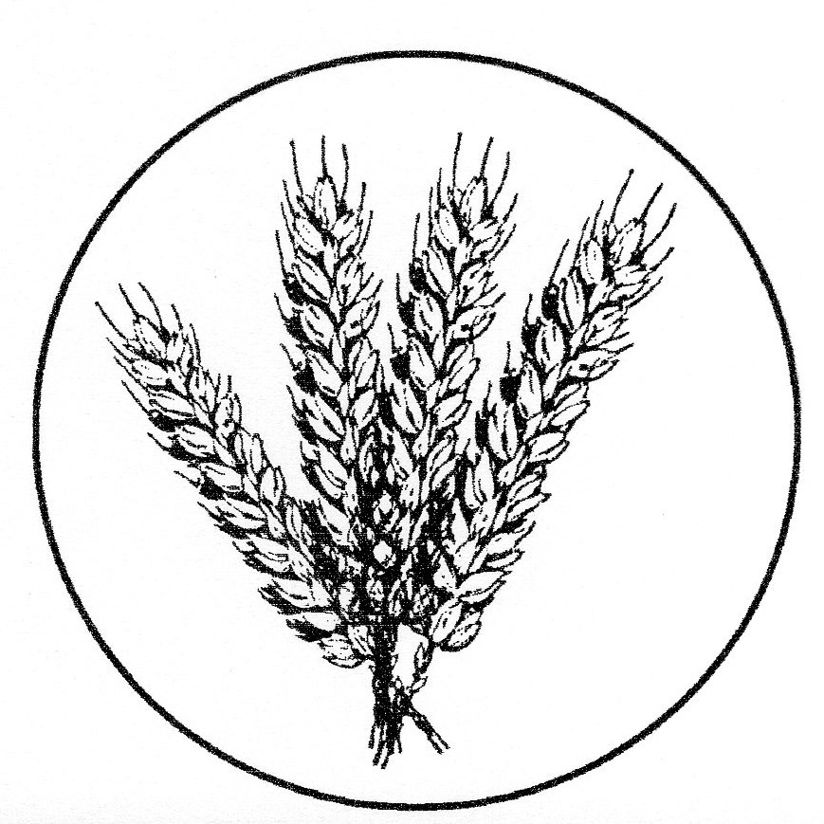
9. RUTH

We read in Ruth 1:15-17:

And she said, “Look, your sister-in-law has gone back to her people and to her gods; return after your sister-in-law.” But Ruth said: “Entreat me not to leave you, or to turn back from following after you; for wherever you go, I will go; and wherever you lodge, I will lodge; your people shall be my people, and your God, my God. Where you die, I will die, and there will I be buried. The LORD do so to me, and more also, if anything but death parts you and me.”

Further in Ruth 4:13, 17-22:

So Boaz took Ruth and she became his wife; and when he went in to her, the LORD gave her conception, and she bore a son. Also the neighbor women gave him a name, saying, “There is a son born to Naomi.” And they called his name Obed. He is the father of Jesse, the father of David.
Now this is the genealogy of Perez: Perez begot Hezron; Hezron begot Ram, and Ram begot Amminadab; Amminadab begot Nahshon, and Nahshon begot Salmon; Salmon begot Boaz, and Boaz begot Obed; Obed begot Jesse, and Jesse begot David.

In the story of Ruth something new is happening in the
history of salvation. It was Abraham who left his home
and way of life for the unknown land of God's
Presence. It was to Abraham's descendants that the
covenant of grace was promised. God promised to
reward Abraham with an eternal inheritance in the
land with his descendants. Moabites were excluded from
those promises. But now this single Moabite woman
was slowly being engrafted into the people of Israel.
She served Israel's God, and God lifted her up.

This story now becomes a part of the history of God's
people. This is the history of our king! This is our
story! In the time of the Judges, when all seemed
hopeless, God worked through a Moabite widow to bring
our king to us.

It is a story of our covenant God, the One who delights to freely give all things to those who seek refuge under the shelter of His wings. It is a story of how in the days when Israel had no king the LORD was preparing the way for Him to raise up a king for them, a king after His own heart. It is a story that reveals to us the nature of our God, the One who has not forsaken His kindness, His steadfast love, His grace to His people.
Naomi only dared to hope for a Kinsman Redeemer for the house of Elimelech, but God planned something far greater than that! He planned for a redeemer for the house of Israel! He planned that through Ruth He might provide Israel with a king, a king after His own heart! And not only king David, but from his line would come the Great King, the Great Redeemer, Jesus Christ. He planned for the coming Messiah, the Human face that would perfectly display God’s amazing grace!
And we are blessed because we know the rest of the story. We know not just how the story of Ruth and Naomi ended, but also how the LORD used Ruth to show His kindness in the sending of His Son, Jesus Christ.

10. DAVID

We read in 2 Samuel 7:8-16 the words of God that Nathan the prophet was to tell David:

“Now therefore, thus shall you say to My servant David, ‘Thus says the LORD of hosts: “I took you from the sheepfold, from following the sheep, to be ruler over My people, over Israel. And I have been with you wherever you have gone, and have cut off all your enemies from before you, and have made you a great name, like the name of the great men who are on the earth. Moreover I will appoint a place for My people Israel, and will plant them, that they may dwell in a place of their own and move no more; nor shall the sons of wickedness oppress them anymore, as previously, since the time that I commanded judges to be over My people Israel, and have caused you to rest from all your enemies. Also the LORD tells you that He will make you a house.
“When your days are fulfilled and you rest with your fathers, I will set up your seed after you, who will come from your body, and I will establish his kingdom. He shall build a house for My name, and I will establish the throne of his kingdom forever. I will be his Father, and he shall be My son. If he commits iniquity, I will chasten him with the rod of men and with the blows of the sons of men. But My mercy shall not depart from him, as I took it from Saul, whom I removed from before you. And your house and your kingdom shall be established forever before you. Your throne shall be established forever.”’”
Ultimately, this blessing upon David is not for David’s own sake, but for the sake of the people of Israel. God wants to bless David and his line because of His promises to Abraham, Isaac and Jacob; because God wants to establish His people and provide a place of peace, security and safety for them. God’s eye is not just on David, but also on Abraham’s descendants, the children of Israel.

This covenant with David builds on the covenant of grace established with Abraham. This covenant with David in turn is the foundation for the covenant of grace that we find ourselves in today. In this covenant of grace, God is everything, God’s promises are everything, God’s promises are rich.

In Acts 13, Paul preached at Antioch in Pisidia and he explained that the promises of 2 Samuel 7 about David’s family were really about Jesus Christ. The author of Hebrews quotes verse 14 of 2 Samuel 7 in Hebrews 1:5 and he applies it directly to Jesus Christ, “I will be His Father, and He will be My Son.” Hebrews says that God was speaking prophetically about Christ. And in Luke 1:32, when the angel appears to Mary, he says that the child to be born “will be great and will be called the Son of the Highest, and the Lord God will give Him the throne of His father David.”

Jesus Christ came from the line of David. God’s promises to David were fulfilled most beautifully and perfectly in the Lord Jesus. And it’s to Him that the Holy Spirit is pointing us in this passage. The Holy Spirit is pointing us to God’s love in Christ, to the gospel.

SING: Psalm 132: 6, 10

6. The LORD has once to David sworn 10. “There I will cause, in David’s line,
an oath from which he will not turn: a horn to sprout, a lamp to shine
“There will to you a child be born, for my Anointed as a sign.
a son who from your line will spring, His enemies I clothe with shame,
whom on your throne I’ll set as king. but him I crown with lustrous fame.”

11. HEZEKIAH

We read in 2 Kings 19: 15, 19, 30 & 31:

Then Hezekiah prayed before the LORD, and said: “O LORD God of Israel, the One who dwells between the cherubim, You are God, You alone, of all the kingdoms of the earth. You have made heaven and earth.

Now therefore, O LORD our God, I pray, save us from his hand, that all the kingdoms of the earth may know that You are the LORD God, You alone.”

And the remnant who have escaped of the house of Judah shall again take root downward, and bear fruit upward.
For out of Jerusalem shall go a remnant, and those who escape from Mount Zion. The zeal of the LORD of hosts will do this.’

Hezekiah, king of Judah, was in the line of the kings following David. He was faithful to the LORD, restoring proper worship in the way the LORD had prescribed for Israel. When Hezekiah prayed this prayer he was facing a dire situation, the invading army of the Assyrians led by Sennacherib. It would have been so tempting for him to see things as hopeless but he looks at the situation completely differently. He confesses in 2 Chronicles 32: With [the king of Assyria] is an arm of flesh, but with us is the LORD our God to help us and to fight our battles. And in his prayer we see his complete trust that Israel were not on their own, they were part of God’s great plan of salvation for His people. And one day, all nations would see that the LORD is God alone, and the Gentiles would worship Him.

SING: Hymn 23: 5, 6

5. Let at the name of Jesus every knee,
from heaven above to depths below the sea,
now humbly bow before his majesty.
Hallelujah, hallelujah!

6. Let every tongue confess that Christ is King,
for he is Lord of all created things.
So to the praise of God the Father sing:
Hallelujah, hallelujah!

INTERVAL

SING: Hymn 48: 1, 2

1. Come praise the Holy Spirit! 2. The gospel of salvation
The prophets he inspired; God has to us revealed,
they after our salvation and we, the Word believing,
unceasingly inquired. were with the Spirit sealed.
They spoke of Christ our Saviour, What none had seen or heard of
of grace that was to be, has been to us declared;
proclaimed to us the wonders what no man had imagined
which angels long to see. God has for us prepared.

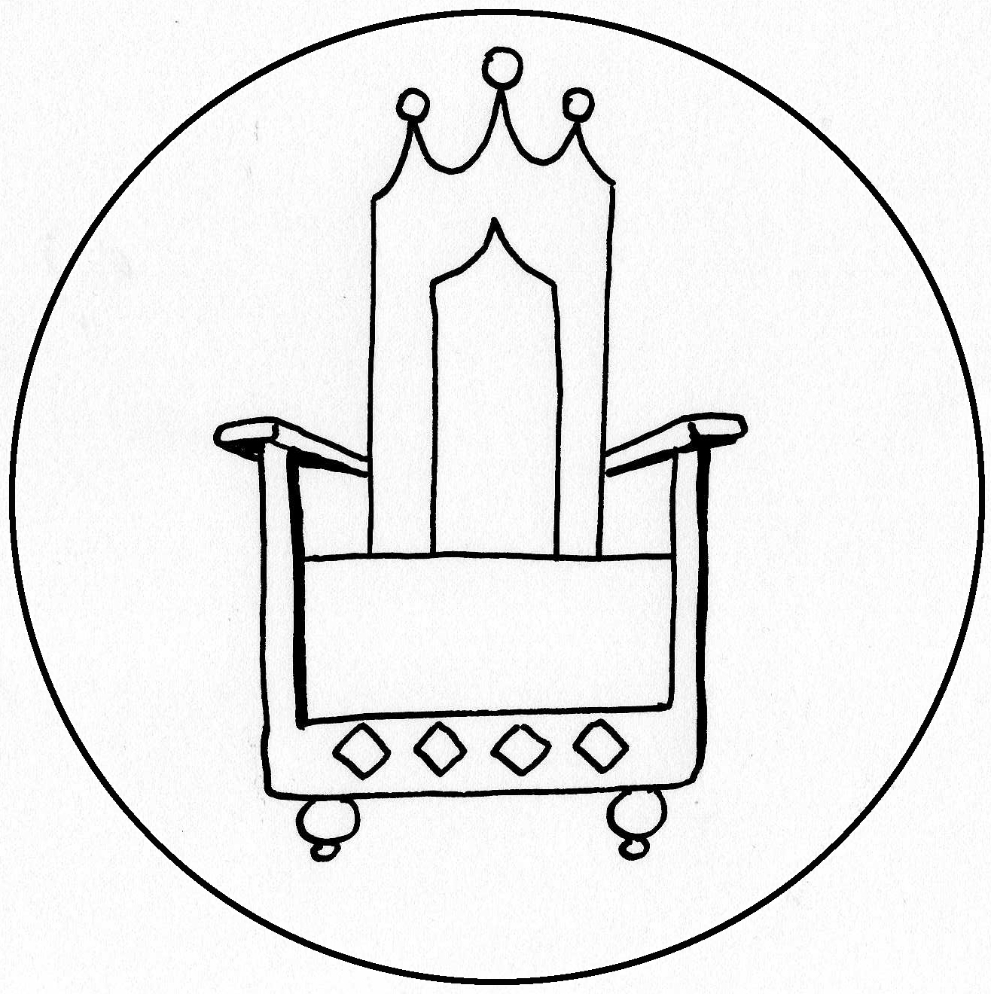
12. ISAIAH

In 1 Peter 1:10 we read: Of this salvation the prophets have inquired and searched carefully, who prophesied of the grace that would come to you.

When we read from the prophets we are reminded again of how God planned every single detail of the path to Christ.

We see in Isaiah 6:5-7 how far we are from the holiness of God. Without God coming to us, we would be totally lost:

So I said: “Woe is me, for I am undone! because I am a man of unclean lips, and I dwell in the midst of a people of unclean lips; for my eyes have seen the King, the LORD of hosts.”
Then one of the seraphim flew to me, having in his hand a live coal which he had taken with the tongs from the altar. And he touched my mouth with it, and said:
“Behold, this has touched your lips; your iniquity is taken away, and your sin purged.”

But a few chapters later we read the glorious promise: Isaiah 9:6 & 7:

For unto us a Child is born, unto us a Son is given; and the government will be upon His shoulder. And His name will be called Wonderful, Counselor, Mighty God, Everlasting Father, Prince of Peace.

Of the increase of His government and peace there will be no end, upon the throne of David and over His kingdom, to order it and establish it with judgment and justice from that time forward, even forever. The zeal of the LORD of hosts will perform this.

Surely this is one of the most well-known prophecies about the coming of Christ. But notice that this is not written as something that will happen, but as something that has already happened. By using the present tense the LORD is impressing on His people that the coming of the Messiah is definite. The plan of salvation that God has worked out is so certain that you could say it has already been done.

SING: Hymn 19: 1, 3, 4

1. The people who in darkness walked
have seen a glorious light;
now day has dawned for those who dwelt
in death’s surrounding night.
To hail you, Sun of Righteousness,
they with rejoicing come
as when with joy they share the spoil
or bear the harvest home.

3. For unto us a Child is born,
to us a Son is given,
and on his shoulders he shall bear
all power in earth and heaven.
The Wonderful, the Counsellor,
the Mighty God is he;
eternal Father, Prince of Peace
his holy name shall be.

4. His government and royal power
shall without end increase,
and he on David’s throne shall reign
in everlasting peace.
On justice and on righteousness
his Kingdom he shall build.
The LORD of hosts will show his zeal:
his word shall be fulfilled!

So many times God revealed to the prophets things that would happen. He didn’t have to. He could have let events unfold as they happened. But foretelling what would happen proves the trustworthiness of God. What God said would happen always did happen. The prophets foretold that because of their unfaithfulness, Israel would be sent into exile, but also that a remnant would return after 70 years. And from that remnant, the Messiah would come. For the Israelites of the Old Testament, God’s promises were their hope. There would never be a time when God was not with them. And in the passage from Jeremiah which follows we see that God promises them a future. God’s great plans for His people Israel are not just for them, but they are based in the coming of the Lord Jesus. The Israelites could be confident in the future because of the Messiah Who was coming.

13. JEREMIAH

Jeremiah 29:4, 8-14:

Thus says the LORD of hosts, the God of Israel, to all who were carried away captive, whom I have caused to be carried away from Jerusalem to Babylon:
…Do not let your prophets and your diviners who are in your midst deceive you, nor listen to your dreams which you cause to be dreamed. For they prophesy falsely to you in My name; I have not sent them, says the LORD.
For thus says the LORD: After seventy years are completed at Babylon, I will visit you and perform My good word toward you, and cause you to return to this place. For I know the thoughts that I think toward you, says the LORD, thoughts of peace and not of evil, to give you a future and a hope. Then you will call upon Me and go and pray to Me, and I will listen to you. And you will seek Me and find Me, when you search for Me with all your heart. I will be found by you, says the LORD, and I will bring you back from your captivity; I will gather you from all the nations and from all the places where I have driven you, says the LORD, and I will bring you to the place from which I cause you to be carried away captive.

SING: Hymn 16: 1, 3

1. O come, O come, Emmanuel,
and ransom captive Israel,
that mourns in lonely exile here,
until the Son of God appear.
Rejoice! Rejoice! Emmanuel
shall come to thee, O Israel.

3. O come, Thou Branch of Jesse’s stem,
regard Thine own and rescue them;
from depths of hell Thy people save,
and give them victory o’er the grave.
Rejoice! Rejoice! Emmanuel
shall come to thee, O Israel.

14. EZRA
As the writer of Proverbs says in chapter 21:1, “The king’s heart is in the hand of the LORD; like the rivers of water, He turns it wherever He wishes.” The LORD turned the heart of Cyrus toward the people of Israel, so that deliverance and restoration were possible, from start to finish.

Not only were the exiled people of God free to return to their land. Not only were they permitted to rebuild the temple. Not only did they receive federal funding for the project. But they even benefitted from royal protection, to see it through to completion. Because God was directing things, no detail was overlooked, no need unmet.

It’s all the work of our God. His is the planning, His is the saving. He remains faithful to His promises.

We read in Ezra 1:1-4:

Now in the first year of Cyrus king of Persia, that the word of the LORD by the mouth of Jeremiah might be fulfilled, the LORD stirred up the spirit of Cyrus king of Persia, so that he made a proclamation throughout all his kingdom, and also put it in writing, saying,

Thus says Cyrus king of Persia:
All the kingdoms of the earth the LORD God of heaven has given me. And He has commanded me to build Him a house at Jerusalem which is in Judah. Who is among you of all His people? May his God be with him, and let him go up to Jerusalem which is in Judah, and build the house of the LORD God of Israel (He is God), which is in Jerusalem. And whoever is left in any place where he dwells, let the men of his place help him with silver and gold, with goods and livestock, besides the freewill offerings for the house of God which is in Jerusalem.

15. ZACHARIAS/JOHN THE BAPTIST

A long period of four hundred years between the Old and New Testaments. Where was God? Where was the fulfilment of His promises? The priests continued to offer their sacrifices, until one day we read of the appearance of the angel Gabriel to the priest Zacharias, serving in the temple of the Lord.

We read in Luke 1:13-17:

But the angel said to him, “Do not be afraid, Zacharias, for your prayer is heard; and your wife Elizabeth will bear you a son, and you shall call his name John. And you will have joy and gladness, and many will rejoice at his birth. For he will be great in the sight of the Lord, and shall drink neither wine nor strong drink. He will also be filled with the Holy Spirit, even from his mother’s womb. And he will turn many of the children of Israel to the Lord their God. He will also go before Him in the spirit and power of Elijah, ‘to turn the hearts of the fathers to the children,’ and the disobedient to the wisdom of the just, to make ready a people prepared for the Lord.”

Matthew 3:1-6:

In those days John the Baptist came preaching in the wilderness of Judea, and saying, “Repent, for the kingdom of heaven is at hand!” For this is he who was spoken of by the prophet Isaiah, saying:
“The voice of one crying in the wilderness: ‘Prepare the way of the LORD; make His paths straight.’”
Now John himself was clothed in camel’s hair, with a leather belt around his waist; and his food was locusts and wild honey. Then Jerusalem, all Judea, and all the region around the Jordan went out to him and were baptized by him in the Jordan, confessing their sins.
16. SONG OF ZACHARIAS

After the birth of his son, Zacharias sings a beautiful song, speaking of God’s faithfulness to His covenant in sending the son of David to be the Redeemer for His people.

We read in Luke 1:67-79:

Now his father Zacharias was filled with the Holy Spirit, and prophesied, saying:
“Blessed is the Lord God of Israel, for He has visited and redeemed His people,
And has raised up a horn of salvation for us in the house of His servant David,
As He spoke by the mouth of His holy prophets, who have been since the world began,
That we should be saved from our enemies and from the hand of all who hate us,
To perform the mercy promised to our fathers and to remember His holy covenant,
The oath which He swore to our father Abraham:
To grant us that we, being delivered from the hand of our enemies, might serve Him without fear,
In holiness and righteousness before Him all the days of our life.
“And you, child, will be called the prophet of the Highest; for you will go before the face of the Lord to prepare His ways,
To give knowledge of salvation to His people by the remission of their sins,
Through the tender mercy of our God, with which the Dayspring from on high has visited us;
To give light to those who sit in darkness and the shadow of death, to guide our feet into the way of peace.”

SING: Song of Zacharias, Hymn 18:1

Blest be the God of Israel,
for he has come to set us free;
in David’s house the Lord has raised
salvation’s horn for all to see.
He through His prophets long ago
said he would save us from our foe,
from all who scorn and hate us.
He has not put our father’s faith to shame
but, in his love remembering them,
has kept the oath he swore to Abraham.

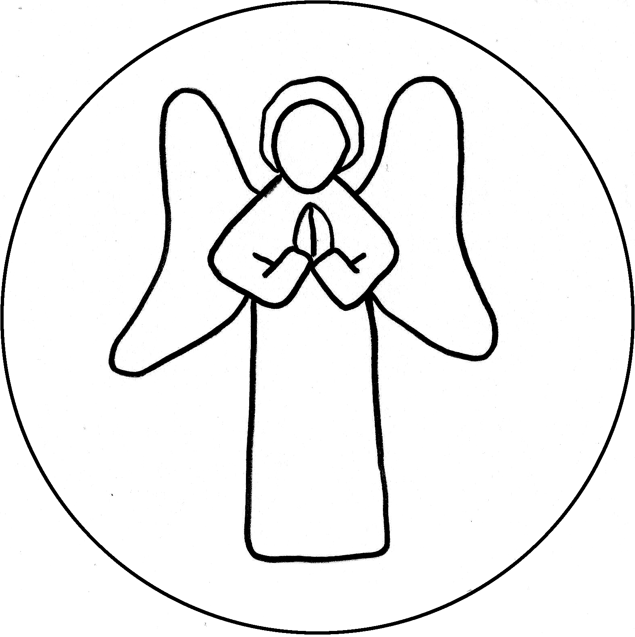
17. MARY
Luke 1:26-33:
Now in the sixth month the angel Gabriel was sent by God to a city of Galilee named Nazareth, to a virgin betrothed to a man whose name was Joseph, of the house of David. The virgin’s name was Mary. And having come in, the angel said to her, “Rejoice, highly favored one, the Lord is with you; blessed are you among women!”
But when she saw him, she was troubled at his saying, and considered what manner of greeting this was. Then the angel said to her, “Do not be afraid, Mary, for you have found favour with God. And behold, you will conceive in your womb and bring forth a Son, and shall call His name JESUS. He will be great, and will be called the Son of the Highest; and the Lord God will give Him the throne of His father David. And He will reign over the house of Jacob forever, and of His kingdom there will be no end.”

18. JOSEPH

Matthew 1:18-25:

Now the birth of Jesus Christ was as follows: After His mother Mary was betrothed to Joseph, before they came together, she was found with child of the Holy Spirit. Then Joseph her husband, being a just man, and not wanting to make her a public example, was minded to put her away secretly. But while he thought about these things, behold, an angel of the Lord appeared to him in a dream, saying, “Joseph, son of David, do not be afraid to take to you Mary your wife, for that which is conceived in her is of the Holy Spirit. And she will bring forth a Son, and you shall call His name JESUS, for He will save His people from their sins.”
So all this was done that it might be fulfilled which was spoken by the Lord through the prophet, saying: “Behold, the virgin shall be with child, and bear a Son, and they shall call His name Immanuel,” which is translated, “God with us.”

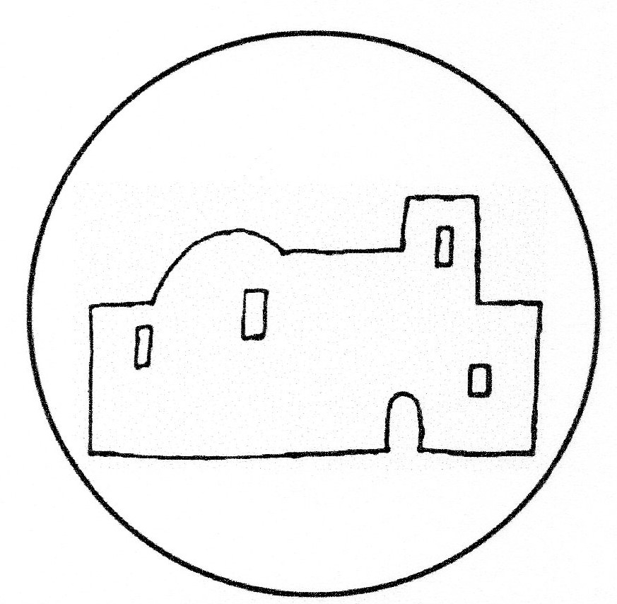
19. BIRTH OF JESUS

Joseph and Mary travelled to Bethlehem because of the census, fulfilling the prophesy that the Messiah would be born in Bethlehem. God directs the hearts of all men, and neither the highest nor the lowest in the land are outside of His control.

We read in Luke 2:1-7

And it came to pass in those days that a decree went out from Caesar Augustus that all the world should be registered. This census first took place while Quirinius was governing Syria. So all went to be registered, everyone to his own city.
Joseph also went up from Galilee, out of the city of Nazareth, into Judea, to the city of David, which is called Bethlehem, because he was of the house and lineage of David, to be registered with Mary, his betrothed wife, who was with child. So it was, that while they were there, the days were completed for her to be delivered. And she brought forth her firstborn Son, and wrapped Him in swaddling cloths, and laid Him in a manger, because there was no room for them in the inn.

SING: Hark the Herald Angels Sing

1. Hark! the herald angels sing,
"Glory to the new born King,
peace on earth, and mercy mild,
God and sinners reconciled!"
Joyful, all ye nations rise,
join the triumph of the skies;
with th' angelic host proclaim,
"Christ is born in Bethlehem!"
Hark! the herald angels sing,
"Glory to the new born King!"

2. Christ, by highest heaven adored;
Christ, the everlasting Lord;
late in time behold Him come,
offspring of a virgin's womb.
Veiled in flesh the Godhead see;
hail th' incarnate Deity,
pleased with us in flesh to dwell,
Jesus, our Emmanuel.
Hark! the herald angels sing,
"Glory to the new born King!"

3. Hail the heaven-born Prince of Peace!
Hail the Sun of Righteousness!
Light and life to all He brings,
risen with healing in His wings.
Mild he lays His glory by,
born that man no more may die,
born to raise the sons of earth,
born to give them second birth.
Hark! the herald angels sing,
"Glory to the new born King!"

20. WISE MEN
Matthew 2:1-6

Now after Jesus was born in Bethlehem of Judea in the days of Herod the king, behold, wise men from the East came to Jerusalem, saying, “Where is He who has been born King of the Jews? For we have seen His star in the East and have come to worship Him.”
When Herod the king heard this, he was troubled, and all Jerusalem with him. And when he had gathered all the chief priests and scribes of the people together, he inquired of them where the Christ was to be born.
So they said to him, “In Bethlehem of Judea, for thus it is written by the prophet:
‘But you, Bethlehem, in the land of Judah, are not the least among the rulers of Judah; for out of you shall come a Ruler Who will shepherd My people Israel.’”

SING: O Come All Ye Faithful (VSS 1, 3, 6)

1. O come all ye faithful, joyful and triumphant,
O come ye, O come ye, to Bethlehem.
Come and behold Him, born the King of angels;
O come let us adore Him,
O come let us adore Him,
O come let us adore Him,
Christ the Lord.

3. Sing, choirs of angels, sing in exultation;
sing, all ye citizens of heaven above!
Glory to God, all glory in the highest;
O come let us adore Him,
O come let us adore Him,
O come let us adore Him,
Christ the Lord.

6. Yea, Lord, we greet Thee, born this happy morning,
Jesus, to Thee be all glory given.
Word of the Father, now in flesh appearing:
O come let us adore Him,
O come let us adore Him,
O come let us adore Him,
Christ the Lord.

*****************************************************************

The gospel message is so clear to us and we thank God for the gift of faith, by which we are able to read and believe His Word. It’s only faith which makes us able to see God’s miraculous plan of salvation that was worked through every event in the Old Testament and fulfilled in the coming of God’s son. It is our Messiah who was born in Bethlehem. From the rulers of Judah came a Ruler to shepherd God’s chosen people. We read in Acts 13:22,23:

And when He had removed (Saul), He raised up for them David as king, to whom also He gave testimony and said, ‘I have found David the son of Jesse, a man after My own heart, who will do all My will.’ From this man’s seed, according to the promise, God raised up for Israel a Saviour—Jesus—

David was a man after God’s own heart, but David’s son, our Lord Jesus Christ, was the only one who could save us.

Let’s go back to the prophesy of Isaiah where he foretells the coming of the Messiah from the stem of Jesse:

Isaiah 11:1-5, 10

There shall come forth a Rod from the stem of Jesse, and a Branch shall grow out of his roots.

The Spirit of the LORD shall rest upon Him, the Spirit of wisdom and understanding, the Spirit of counsel and might, the Spirit of knowledge and of the fear of the LORD.
His delight is in the fear of the LORD, and He shall not judge by the sight of His eyes, nor decide by the hearing of His ears;

But with righteousness He shall judge the poor, and decide with equity for the meek of the earth; He shall strike the earth with the rod of His mouth, and with the breath of His lips He shall slay the wicked.

Righteousness shall be the belt of His loins, and faithfulness the belt of His waist.

And in that day there shall be a Root of Jesse, Who shall stand as a banner to the people; for the Gentiles shall seek Him, and His resting place shall be glorious.

By the grace of God, we, who were once of the Gentiles, are given the gift of faith, the tremendous privilege of being adopted as God’s beloved children. Knowing the love and mercy of God, we are of all people the most to be envied, because we have the certain hope of a blessed eternity with the Almighty God, our Father for Christ’s sake.

At Christmas we celebrate the birth of Christ, a new beginning. But we also celebrate the grace of the Father, who planned all things from eternity and controlled every event in history, so that the Messiah could come into the world as a fulfilment of His promises.

What a faithful God we have. Let’s praise Him by singing ……

SING: HYMN 66: 1,2

1. Great is Thy faithfulness, O God my Father,
there is no shadow of turning with Thee;
Thou changest not, Thy compassions, they fail not;
as Thou hast been Thou forever wilt be.

Refrain:
Great is Thy faithfulness! Great is Thy faithfulness!
Morning by morning new mercies I see;
all I have needed Thy hand hath provided.
Great is Thy faithfulness, Lord, unto me!

2. Summer and winter and springtime and harvest,
sun, moon, and stars in their courses above
join with all nature in manifold witness
to Thy great faithfulness, mercy, and love.

Refrain

3. Pardon for sin and a peace that endureth,
Thy own dear presence to cheer and to guide,
strength for today and bright hope for tomorrow –
blessings all mine, with ten thousand beside!

Refrain

PRAYER

