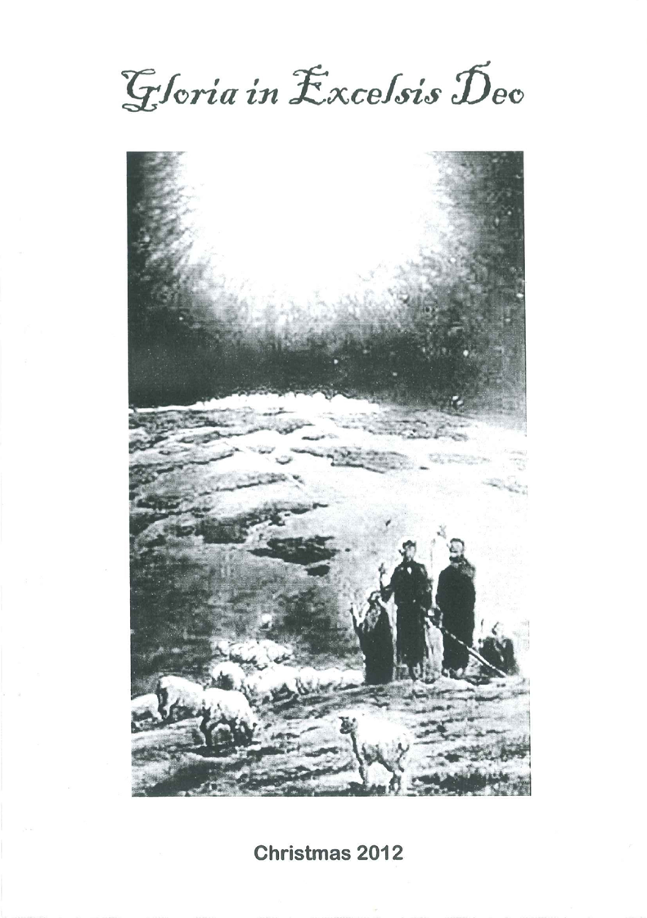
Christmas 2012

Singing Psalm 145: 1

I will exalt you, O my God and King,
and bless your name forever as I sing.
Yes, daily blessing you, I will adore
and praise your holy name for evermore.
Great is the LORD, worthy of praise unending;
his greatness is beyond all understanding.
One age will to the next pro-claim the story
of his great deeds, his acts of might and glory.

Prayer

Welcome

Reading Isaiah. 48: 17-19

17 Thus says the Lord, your Redeemer, The Holy One of Israel: "I am the Lord your God, Who teaches you to profit, Who leads you by the way you should go.
18 Oh, that you had heeded My commandments! Then your peace would have been like a river, And your righteousness like the waves of the sea.
19 Your descendants also would have been like the sand, And the offspring of your body like the grains of sand; His name would not have been cut off Nor destroyed from before Me."

Singing Ps 105:2 and 3
Turn to the LORD, who fails us never,
and seek his face, his strength, forever.
Recall the wonders he has wrought,
the righteous judgments he has taught.
Remember these, you chosen ones,
O Abra’m's offspring, Jacob's sons.

He is the LORD, our God unfailing,
his judgments everywhere prevailing.
He will remember and uphold
his cov’nant made in days of old.
The steadfast words of his command
a thousand generations stand.

Singing Hymn 16:1, 4 and 5
O come, O come, Emmanuel,
and ransom captive Israel,
that mourns in lonely exile here,
until the Son of God appear.
Rejoice! Rejoice! Emmanuel
Shall come to thee, O Israel.

O come, thou Dayspring from on high
and comfort us by drawing nigh;
disperse the gloomy clouds of night,
and death's dark shadows put to flight.
Rejoice! Rejoice! Emmanuel
shall come to thee, O Israel.

O come, thou who hast David's key,
save us, that we eternally
in paradise regained may dwell;
forever shut the gates of hell.
Rejoice! Rejoice! Emmanuel
shall come to thee, O Israel.

Reading Isaiah 40:1-5
1 "Comfort, yes, comfort My people!" Says your God.
2 "Speak comfort to Jerusalem, and cry out to her, That her warfare is ended, That her iniquity is pardoned; For she has received from the Lord's hand Double for all her sins."
3 The voice of one crying in the wilderness: "Prepare the way of the Lord; Make straight in the desert A highway for our God.
4 Every valley shall be exalted And every mountain and hill brought low; The crooked places shall be made straight And the rough places smooth;
5 The glory of the Lord shall be revealed, And all flesh shall see it together; For the mouth of the Lord has spoken."

Singing Hymn 15
Comfort, comfort now my people;
speak of peace: so says our God.
Comfort those who sit in darkness,
mourning under sorrows load.
Cry out to Jerusalem
of the peace that waits for them;
tell her that her sins I cover
and her warfare now is over.

For the herald's voice is crying
in the desert far and near,
calling all men to repentance,
since the kingdom now is here.
O that warning voice obey!
Now prepare for God a way.
Let the valleys rise to meet him,
And the hills bow down to greet him.

Then make straight what long was crooked,
Make the rougher places plain.
Let your hearts be true and humble
as befits his holy reign.
For the glory of the LORD
now on earth is shed abroad,
and all flesh shall see the token
that his word is never broken.

Singing Oh, Come, All Ye Faithful
Oh, come all ye faithful, joyful and triumphant!
Oh, come ye, oh, come ye to Bethlehem;
Come and behold him born the king of angels:
Oh, come, let us adore him, Oh, come, let us adore him, Oh, come, let us adore him, Christ the Lord.

Sing, choirs of angels, sing in exultation,
Sing, all ye citizens of heaven above!
Glory to God in the highest:
Oh, come, let us adore him, Oh, come, let us adore him, Oh, come, let us adore him, Christ the Lord.

Yea, Lord, we greet thee, born this happy morning; Jesus, to thee be glory given!
Word of the Father, now in flesh appearing!
Oh, come, let us adore him, Oh, come, let us adore him,
Oh, come, let us adore him, Christ the Lord.

Reading Luke 1: 26 – 28
26 Now in the sixth month the angel Gabriel was sent by God to a city of Galilee named Nazareth,
27 to a virgin betrothed to a man whose name was Joseph, of the house of David. The virgin's name was Mary.
28 And having come in, the angel said to her, "Rejoice, highly favored one, the Lord is with you; blessed are you among women!"

Reading John Stott - The Annunciation

Singing Hymn 17 : 1 and 3
My soul does magnify
the Lord, for he most high
has shown to me his favour.
I praise him with my voice;
My spirit does rejoice
in him, my God and Saviour.

How holy is his name!
The Mighty One, he came
And showed me his great favour.
With mercy he is near
To all who him rfevere;
His love endures forever.

Singing Once in royal David's city
He came down to earth from heaven,
who is God and Lord of all,
and his shelter was a stable,
and his cradle was a stall;
with the poor, the scorned, the lowly,
lived on earth our Savior holy.
And our eyes at last shall see him,
through his own redeeming love;
for that Child who seemed so helpless
is our Lord in heaven above;
and he leads his children on
to the place where he is gone.

Reading  Reading | John Stott - Bethlehem  Luke 2: 13 and 14  13 And suddenly there was with the angel a multitude of the heavenly host praising God and saying:  14 "Glory to God in the highest, And on earth peace, goodwill toward men!"  Suddenly a great company of the heavenly host appeared with the angel, praising God and saying, "Glory to God in the highest heaven, and on earth peace to those on whom his favour rests."

Singing Hymn 21:1 , 5 and 6

While shepherds watched their flocks by night,
all seated on the ground,
an angel of the Lord came down
and glory shone around.

Then with the angel, all at once,
appeared a mighty throng –
a glorious heav'nly multitude,
all praising God in song:

"All glory to our God on high
and on the earth his peace
for men to whom he favour shows
which nevermore shall cease."

Reading Luke 2: 20
20 Then the shepherds returned, glorifying and praising God for all the things that they had heard and seen, as it was told them.

Reading John 3: 16
16 For God so loved the world that He gave His only begotten Son, that whoever believes in Him should not perish but have everlasting life.

Reading Isaiah 53: 4 and 5
4 Surely He has borne our griefs And carried our sorrows; Yet we esteemed Him stricken, Smitten by God, and afflicted.
5 But He was wounded for our transgressions, He was bruised for our iniquities; The chastisement for our peace was upon Him, And by His stripes we are healed.

Singing Hymn 23:1, 3 and 6
Let us of Christ our Lord and Sav-iour sing,
for, though God's equal, though eternal King,
he did not to his rightful glory cling.
Hallelujah, hallelujah!

He bore the weakness of our human frame
and he obedient unto death became,
for on a cross he died, in bitter shame.
Hallelujah, hallelujah!

Let every tongue confess that Christ is King,
for he is Lord of all created things.
So to the praise of God the Father sing:
Hallelujah, hallelujah!

Reading Revelation 1 : 8 and 18a
Jesus declares of Himself:
8a "I am the Alpha and the Omega!
18a I am He who lives, and was dead, and behold, I am alive forevermore!”

Reading And the church of all ages confesses of Him that: On the third day He arose from the dead; He ascended into heaven, and sits at the right hand of God the Father almighty; from there He will come to judge the living and the dead.

Singing Hymn 3 : 4
You are enthroned in glory at God's own right hand,
till you from there as judge will on the clouds descend.
O Lord, we therefore pray, grant help and vindication
to those who through your precious blood have gained salvation.
In everlasting glory add them to the number
of all your saints, O Lord. Your heritage remember!

Hymn 68 : 6 and 8
When we hear the trumpet's sound
and the dead are raised immortal,
we shall see with joy profound
how the grave must serve as portal
leading past all woe and strife
into everlasting life.

To our God be thanks and praise:
he through Christ made us victorious.
Be then steadfast all your days;
see how death's defeat assures us
that in him who comes again
all your toil is not in vain.

Quiz

Singing Thank you Lord, for this year
1.Thank you Lord, for this year,
With its joy and its sorrow.
Thank you, Lord, keep us near,
Give us strength for tomorrow.
Glory to God, may he guide us on,
Guide us on to forever.
Thank you Lord, for this year,
With its joy and its sorrow.

2.Thank you Lord, for this day,
For your blessings abounding.
Thank you Lord, with us stay,
Hear our praises resounding.
Glory to God, may he guide us on,
Guide us on to forever.
Thank you Lord, for this day,
For your blessings abounding.

General Business and Announcements
Closing Prayer
Singing Hymn 67:1, 2, 6 and 7

Come Lord Jesus Maranatha
pray the Spirit and the Bride.
Come upon the clouds of heaven
With your angels at your side.
Maranatha! Come, Lord Jesus!
Evermore with us abide.

Come, O Lord, with pow’r and glory
and descend before our eyes
when the sounding of the trumpet
shall re-echo through the skies
and the voice of your archangel
shall command the dead to rise.

Then let your refining Spirit
us with flaming ze3al endue.
May we wait with eager longing
for your promise to come true
when you, Lord, with fire from heaven
all creation will renew..

No one knows the day or moment
when the Bridegroom shall appear.
Let us then be ever watchful;
may our lamps be bright and clear.
Maranatha! Come, Lord Jesus!
Your great day is drawing near.

