Come let us adore Him

The 1986 Christmas Program of the Albany John Calvin School

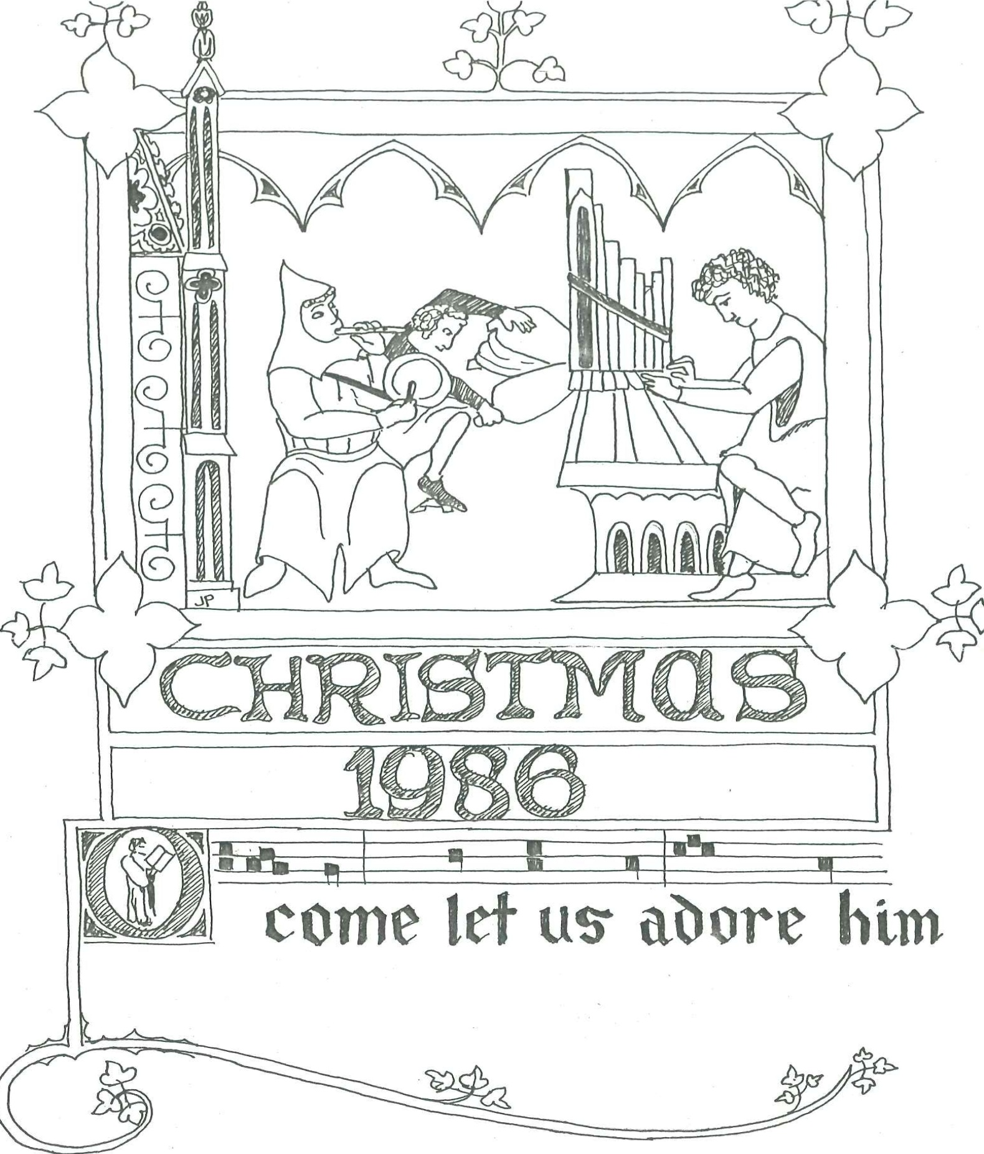

COMMUNITY SINGING: Psalm 100
You lands and peoples of the earth
before the LORD your joy shout forth.
Serve Him with gladness all your days
and come to Him with songs of praise.

Know that the LORD is God alone;
He made us, and we are His own,
the sheep that he to pasture leads
and as their shepherd guards and feeds.

Come, enter then His gates with praise
and in His courts your voices raise.
Give thanks to Him and bless His Name;
within His house your joy proclaim.

The LORD is good, and evermore
His love and mercy will endure.
All generations He will bless
in His unchanging faithfulness.

OPENING

1.I SCHOOL SINGING: "O Come, All Ye Faithful"
O come, all ye faithful
Joyful and triumphant
O come ye, O come ye to Bethlehem;
Come and behold Him
Born the King of angels.
Refrain:
O come, let us adore Him,
O come, let us adore Him,
O come, let us adore Him, Christ, the Lord.

Sing, choirs of angels
Sing in exultation
O sing, all ye bright hosts of heaven above
Glory to God, all
Glory in the highest.
Refrain:

Yes, Lord, we greet Thee
Born this happy morning
Jesus to Thee be all glory given
Word of the Father,
Now in flesh appearing.
Refrain:

2. RECITATION - Year 6 and 7

In the beginning, the first beginning,
The very beginning was God.
God spoke His Word and created the world
Heaven and Earth. No, not

From dust or clay or elements
Or from one little part.
No, not with hands and not with tools
as artists create art.

God spoke one Word, one mighty Word;
He spoke the light and called it day,
He spoke the sky in wondrous way,
He spoke the land, He spoke the sea,
The sun and moon and stars spoke He,
He spoke ... really, there is no end
To what appeared at His command:

The fowl and fish, both great and small
The animals, God spoke them all.
A world of life, a world of love,
Both earth below and heaven above
One image of His magnitude
Ready to render gratitude
To Him who spoke.

In this new world, this brand new world,

This brilliant world stood man,
He knew his God, he knew His voice,
He knew His great command.

He looked away from what was good,
And reached for the forbidden fruit;
He listened to God's enemy
And he despised God's company.
He took the "step ahead" and fell,

Forgetting all He knew so well
The love of God, the grace of God,
The burning jealousy of God.
He fell ...

3. COMMUNITY SINGING: Hymn 10: 1, 6, 8
Lord, I have heard the tidings
of You and of your might.
Your deeds reveal your greatness;
I tremble at their sight.
Lord, in our time renew them;
In our day make them known.
In wrath remember mercy;
Do not forget your own!

Your glittering spear and arrows
made sun and moon stand still.
You, marching on in fury,
made earth in terror kneel.
You, trampling down the nations,
came with Your dreadful wrath
to rescue your own people,
to clear for them a path.

I hear your steps approaching
and at their sound I quake.
Lips quiver, bones are trembling;
I totter and I shake.
In quiet expectation
I shall await the day
when those who now invade us
will all be swept away.

4. RECITATION - Year 8 and 9
The Lord called to Adam and said to him "Where are you?"

"I have Your voice in the garden and I was afraid ..."

Have you eaten from the tree of which I commanded you that you should not eat?"

“The woman whom You gave to with me, she gave me of the fruit, and I ate."

"What is this that you have done?

“The serpent deceived me, and I ate."

The LORD said to the serpent:
"I will put enmity between you and the woman, and between your seed and her Seed; he shall bruise your head, and you shall bruise His heel".

5. SCHOOL SINGING: "Unto Us a Child is Born"
Unto us a child is born,
King of all creation:
Cradled in a stall was He,
The Lord of every nation.
The Lord of every nation.

Herod then with fear was filled:
"A prince", he said, "in Jewry!"
All the little boys he killed
At Bethlehem in his fury,
At Bethlehem in his fury.

Enmity between God's Son,
And the wicked serpent,
Thus we know He is the One
Whom the Lord has promised,
Whom the Lord has promised.

Omega and Alpha He!
Let the organ thunder,
While the choir with peals of glee
Doth rend the air asunder.
Doth rend the air asunder.

6. COMMUNITY SINGING: Hymn 15: 1, 2
Comfort, comfort now My people,
Speak of peace, so says our God!
Comfort those who sit in darkness,
mourning under sorrow's load.
Cry out to Jerusalem
of the peace that waits for them;
Tell her that her sins I cover,
and her warfare now is over.

For the herald's voice is crying
in the desert far and near,
Calling all men to repentance,
since the Kingdom now is here.
O that warning voice obey!
Now prepare for God a way.
Let the valleys rise to meet Him,
and the hills bow down to greet Him.

7. RECITATION: Year 4 and 5
John 3:16
"For God so loved the world that He gave us His only begotten Son, that whoever believes in Him should not perish, but have everlasting life."

Isaiah 9:6
"For unto us a child is born, unto us a Son is given; and the government will be upon His shoulder.
And His name will be called WONDERFUL, COUNSELLOR, MIGHTY GOD, EVERLASTING FATHER, PRINCE OF PEACE."

Jeremiah 33:15
“Thus says the LORD: 'In those days and at that time I will cause to grow up to David a Branch of righteousness; He shall execute judgement and righteousness in the earth'."

8. SCHOOL SINGING: "Once in Royal David's City"
Once in royal David's city Stood a lowly cattle shed
Where a mother laid her baby in a manger for His bed!
Mary was that mother mild, Jesus Christ her little child.

He came down to earth from heaven, Who is God and Lord of all,
And His shelter was a stable, and His cradle was a stall;
With the poor and mean and lowly Lived on earth our Saviour holy.

God His promise has remembered in His own redeeming love
Comfort, comfort to His people, Glory be to God above.
On His father David's throne Christ has come unto his own.

Not in that poor lowly stable with the oxen standing by,
Shall we see Him; but in heaven, Set at God's right hand on high; Where His children shall be crowned Hallelujah's shall resound.

9. RECITATION: Luke 2:8-12 - YEAR 10
"Now there were in the same country shepherds living out in the fields, keeping watch over their flock by night. And behold an angel of the Lord stood before them, and the glory of the Lord shone around them, and they were greatly afraid. Then the angel said to them:
"Do not be afraid; for behold, I bring you good tidings of great joy which will be to all the people; for there is born to you this day in the city of David a Saviour who is Christ the Lord. And this will be the sign to you: you will find a Babe wrapped in swaddling cloths, lying in a manger."

10. SCHOOL SINGING: "Shepherds Do You Understand?" - LOWER PRIMARY
Shepherds, do you understand?
Christ is born to tend you.
Shepherds, with your staff in hand,
go where angels send you.
Angels sing their new refrain;
God is helping man again.
Trust your flock to Him;
Go to Bethlehem.
In the manger straw is sleeping
what you've long been seeking..

Wise men, do you understand?
Christ is born to teach you.
Calling you from distant lands,
His bright star will lead you.
Pack your gifts safe and secure
Gold and frankincense and myrrh.
Where you are to go,
Heaven's star will show.
In the manger straw is sleeping
what you've long been, seeking.

People, do you understand?
Christ is born to save you.
Brand new life is now at hand,
Coming down above you.
Peace on earth, goodwill to men;
We are one with God again.
God has made it clear.
He is with us here.
In the manger straw is sleeping
what you've long been seeking.

11. RECITATION: John 1:14 - YEAR 2 AND 3
"And the Word became flesh and dwelt among us, and we beheld His glory as of the only begotten Son of the Father
full of grace and truth;”

12. SCHOOL SINGING: "Hark! The Herald Angels Sing"
Hark! The herald angels sing, Glory to the new-born King,
Peace on earth and mercy mild, God and sinners reconciled. Joyful all ye nations rise, Join the triumph of the skies;
With angelic host proclaim "Christ is born in Bethlehem".
Hark! The herald angels sing, Glory to the new-born King.

Christ, by highest heaven adored, Christ, the everlasting Lord,
Late in time behold Him come, Offspring of the virgin's womb, Veiled in flesh, the Godhead see! Hail, the incarnate Deity!
Pleased as man with man to dwell, Jesus, our Emmanuel.
Hark! The herald angels sing, Glory to the newborn King.

Hail, the heaven-born Prince of Peace! Hail the Sun of Righteousness.
Light and life to all He brings, Risen with healing in His wings.
Mild He lays His glories by, Born that man no more may die,
Born to raise the sons of earth, Born to give them second birth. Hark! The herald angels sing Glory to the newborn King.

13. COMMUNITY SINGING: Hymn 25: 2, 3, 6
See how He grew up like a tender plant
And sprouted like a root in arid land.
He had no form or beauty to command
our adoration.
He was despised and by mankind rejected –
a man of sorrows, burdened and afflicted.
His greatness was not noticed or respected:
We shrank from Him.

Our suff’rings and infirmities He bore;
Our sorrows He was willing to endure,
While we thought He was being punished for
His own wrongdoing.
But He was pierced because of our transgression,
Bruised for our sin: His punishments and passion
procured our peace; His scourgings and oppression
Healed us again.

With wicked men they Him a grave assigned,
but then a rich man Him a tomb did find,
since He had not been to deceit inclined,
for He was blameless.
It was God’s will to grieve Him by oppression:
He made His Son an off'ring for transgression.
He, when at last He has fulfilled His mission
shall see His seed.

14. SCHOOL SINGING: "God Rest You Merry, Gentlemen"
God rest you merry, gentlemen,
Let nothing you dismay,
Remember Christ our Saviour was born on Christmas Day,
To save us all from Satan's power
When we were gone astray.
Refrain:
O, tidings of comfort and joy, Comfort and joy,
O, tidings of comfort and joy.

Fear not, thus said the angel,
Let nothing you affright
A saviour has been born to you In Bethlehem this night,

To free all those that trust in Him
From Satan's pow’r and might.
Refrain:

Now to the Lord sing praises,
All you who fear His Name,
For trusting in His promises you'll not be put to shame.
He was, and is, and yet shall be
for evermore the same.
Refrain:

15. RECITATION: Romans 8: 31b, 32 –
"If God is for us, who can be against us? He who did not spare His own Son but delivered Him up for us all how shall He not with Him also freely give us all things?"

16. RECORDER ENSEMBLE - SECONDARY RECORDER GROUP
3 Carols

17. SCHOOL SINGING: "Christ is Risen"
Christ is risen burst His prison
Let us hymns of triumph sing
For our sadness turned to gladness
Death today has lost its sting.
Refrain:
Alleluia, Alleluia! Soli Deo Gloria! (2x)

Let our living Be thanksgiving
For what God in Christ has done.
Bow before Him and adore Him
Jesus Christ, God's only Son.
Refrain

At the dawning of the morning
He'll return from heaven on high.
Christ descending, we ascending:
Meet each other in the sky.
Refrain:

18. RECITATION – Years 6 and 7
Acts 2:39
"For the promise is to you and to your children and to all who are afar off, as many as the Lord our God will call."

"Who shall separate us from the love of Christ?
Shall tribulation or distress, or persecution or famine or nakedness, or peril or sword?"
"For I am persuaded that neither death nor life, nor angels, nor principalities, nor powers, nor things present, nor things to come, nor height nor depth, nor any other created thing, shall be able to separate us from the love of God which is in Christ Jesus our Lord."

19. COMMUNITY SINGING: Hymn 35:4
I am convinced that neither powers, death nor life,
nor angels, things to come, things present, princes, strife,
nor height, nor depth, nor any other thing created
will from the love of God now keep us separated -
His love in Jesus Christ, the Saviour, whom He gave us
that through His precious blood He might redeem and save us.

20. SCHOOL SINGING: “Joy to the World” – Upper Primary
Joy to the world! The Lord is come!
Let earth receive her King!
Let every heart prepare Him room
and heaven and nature sing,
and heaven and nature⁻sing
and heaven, and heaven and nature sing.

Joy the earth! The Saviour reigns!
Let men their songs employ!
While field and floods, rocks, hills and plains
repeat the sounding joy
repeat the sounding joy

repeat, repeat the sounding joy.

He rules the world with truth and grace,
and makes the nations prove
the glories of His righteousness
and wonders of His love
and wonders of His love
and wonders, wonders of His love.

21. RECITATION: Matthew 24: 30, 31
“Then the sign of the Son of Man will appear in heaven and then all the tribes of the earth will mourn, and they will see the Son of man coming on the clouds of heaven with power and great glory; and He will send His angels with a great sound of a trumpet and they will gather together His elect from the four winds, from one end of heaven to the other."

22. SCHOOL SINGING! "We'll See Him on the Clouds"
We'll see Him on the clouds when He comes, We
shall see Him, we shall see Him.
We'll see Him on the clouds when He comes, in
might and majesty.
Refrain:
Alleluia, shout with joy before the Lord,
He is mighty
He is mighty
Alleluia, shout with joy before the Lord,
He is King of heaven and earth.

We'll all be with Him when He comes, We’ll be
with Him, We'll be with Him,
We'll be with Him when He comes, in
all eternity.
Refrain:

23. CLOSE

24. COMMUNITY SINGING: Hymn1
I believe in God the Father, Almighty
Maker of heav'n and earth.
And in Jesus Christ, His only begotten Son, our Lord;
Who was conceived by the Holy Spirit,
born of the virgin Mary;
suffered under Pontius Pilate;
was crucified, dead, and buried;
He descended into hell;
the third day He rose again from the dead;
He ascended into heav'n,
and sitteth at the right hand of God the Father Almighty;
from thence He shall come to judge the living and the dead.
I believe in the Holy Spirit;
I believe in a holy catholic Church,
the communion of saints;
the forgiveness of sins;
the resurrection of the body;
and the life everlasting. Amen.

