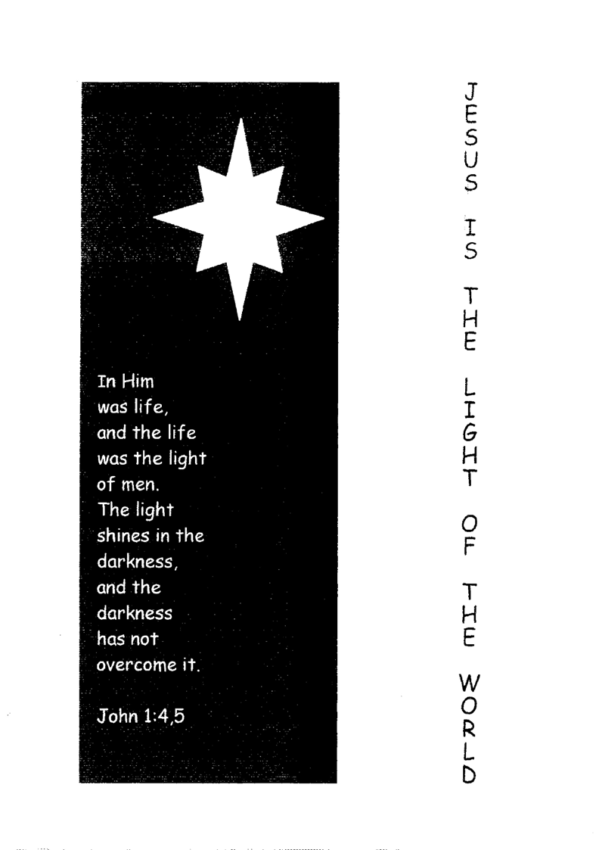
Christmas Program - JESUS IS THE LIGHT OF THE WORLD

Opening
Sing Hymn 18 : 1, 3
Blest be the God of Israel,
for he has come to set us free;
In David’s house the Lord has raised
salvation’s horn for all to see.
He through his prophets long ago
said he would save us from our foe,
from all who scorn and hate us.
He has not put our fathers’ faith to shame
but, in his love rememb’ring them,
has kept the oath he swore to Abraham.

As God has promised, all our sins
will be forgiven, swept away.
He from on high in tender love
will bless us with the glorious day
on which before our very eyes
the radiant Morning Sun will rise
to shine on us forever.
From death’s dark shadow he will grant release
and, when its tyranny shall cease.
will guide our feet into the path of peace.

Prayer

Bible reading - John 1 : 1 – 5
1 In the beginning was the Word, and the Word was with God, and the Word was God.
2 He was in the beginning with God.
3 All things were made through Him, and without Him nothing was made that was made.
4 In Him was life, and the life was the light of men.
5 And the light shines in the darkness, and the darkness did not comprehend it.
Welcome
Apologies
Sing Ps 36 : 3
In your light we see light, O LORD’
You are the fount from which is poured
Life bountiful and precious.
Let not your caring love depart
From those who are of upright heart;
For evermore be gracious.
O let me not by men of pride
Be trampled down or pushed aside
And scornfully mistreated.
See how God vidicates his own;
There lie the wicked, overthrown
And utterly defeated!
Recitation

Ps 82:5a
5 They do not know, nor do they understand; they walk about in darkness;

Proverbs 4 : 19 – 21
19 And this is the condemnation, that the light has come into the world, and men loved darkness rather than light, because their deeds were evil.
20 For everyone practicing evil hates the light and does not come to the light, lest his deeds should be exposed.
21 But he who does the truth comes to the light, that his deeds may be clearly seen, that they have been done in God."

Sing Ps 14 : 1 ,2, 3

The fool says in his heart, 'There is no God".
They are corrupt, their horrid deeds they cherish
Not one of them does good, while just men perish. None calls upon the LORD, none sings His laud
Or fears His rod.

The LORD looks down from heaven's holy throne
To see if anyone has understanding.
not one seeks God, but wickedness intending,
the sons of men, to sin and evil prone,
his law disown.
Will evildoers never understand?
As they would eat their bread, they are devouring
my helpless people. God they are ignoring;
they do not pray, but evil they have planned
throughout the land.

Recitation
Micah 7 : 8
8 Do not rejoice over me, my enemy; When I fall, I will arise; When I sit in darkness, The Lord will be a light to me.
Ecclesiastes 2 : 13
13 Then I saw that wisdom excels folly as light excels darkness.
Psalm 119 : 105, 130
105 Your word is a lamp to my feet And a light to my path.
130 The entrance of Your words gives light; It gives understanding to the simple.

Sing Ps 119 : 40
Your word, it is a lamp to guide my feet
A lantern shining on the path before me.
I've sworn an oath and here my vow repeat
To keep the laws that of your love assure me.
I suffer in affliction and defeat
True to your promise, comfort and restore me.

Sing Ps 27 : 1
God is my light, my refuge, my salvation
Whom shall I fear? The LORD comes to my aid He is my strength in all my tribulation
Of whom shall I then ever be afraid?
When foes who seek my life close in on me They all shall stumble and in anguish flee
And though an army should in war draw near
I will be confident, I will not fear.

Meditation 1 - Isaiah 9:2
2 The people who walked in darkness have seen a great light; Those who dwelt in the land of the shadow of death, upon them a light has shined.
These words of Isaiah 9:2 are familiar to us, especially at this time of the year. Where was this land of deep darkness?" According to the preceding verse it was the land of Zebulon, Naphtali and Asher. This was the area to the north and west of the Sea of Galilee, in the northern part of Canaan, or in other words, the New Testament Galilee.
Right from the beginning of the inhabiting of Canaan this area was never completely Israelite, it also had foreign inhabitants. Indeed, much of Canaan had this problem, but only of Asher and Naphtali is it said - 'they dwelt among the Canaanites" (Judges 1:31-33), rather than the Canaanites lived among them. The Canaanites were very strong, and thus it
can be expected that they exerted quite some negative influence over the Galileans. This situation was less than desirable. Somehow the people of Naphtali, Asher and Zebulon were treated as second class citizens, as seems evident from Solomon's treatment of part of this area.
King Solomon was very active building, first building the temple of the Lord and then his own palace. However, as a result of this he became heavily indebted to King Hiram of Tyre who had supplied much cedar and cypress timber as well as gold, as much as he desired. What did Solomon do then? He "gave to Hiram 20 cities in the land of Galilee." (1 Kings 9:11). Apparently they were to be payment for his debts. From this action of Solomon, one gets the idea that Galilee was dispensable. Although part of the promised land, inhabited by God's covenant people, these cities were deeded over to a heathen king. However King Hiram did not think much of this offer as the cities were in disrepair, and Solomon had to take them back, rebuild them and, it would seem, reluctantly keep them as part of his nation. Poor Israelites - who had always lived there - a people dwelling in darkness. It is clear that One greater than Solomon was needed.
Throughout the time of the kings, Galilee was among the people of Israel who rejected God as their Lord, and was plunged into apostasy. But Galilee's lot was much worse than that of most of the Northern tribes. For over half of the time of the existence of the Northern Kingdom Galilee was under the rule of the Syrians. Ten years before the exile of the Northern Kingdom, Galilee was already in exile, taken by Tiglath-Pilesar, king of Assyria. (2 Kings 15:29)
And it is at this time that Isaiah ministered in the land of Judah and prophesied the words: "The people who have walked in darkness have seen a great light, those who dwell in a land of deep darkness, on them has the light shined." So certain is this prophesy that it is written as if it had already happened.
This prophesy had its initial fulfillment in the days of Hezekiah of Judah. He reopened the temple of the Lord in Jerusalem and reinstituted its service. He also invited Judah and what was left of the Northern Kingdom, including Galilee, to celebrate the Passover feast. He urged the people to repent and return to the Lord their God. Here was gospel proclamation! Here was light in the darkness! And the believers came from Galilee, even thought there were only a few. (2 Chronicles 30:11). The joy in Jerusalem was great. The bond with the God of the covenant was renewed. In the days of King Josiah light again shone for those in Galilee.
Although these rays of light in the history of Galilee were very impressive and encouraging for the faithful remnant, it was clear that the fulfillment of this prophesy could only come in Jesus Christ. Then the light shone through the darkness of that part of the promised land that had been despised and rejected, that had been disobedient and chastised by God
Himself. Also as the One Who fulfilled the prophesy of Isaiah 9:2, the Lord Jesus could say: "I am the light of the world, he who follows Me will not walk in darkness, but will have the light of life." (John 8:12).
Yes, Galilee had a troubled, dark history, and yet it was here that God let His light shine. While Jesus was on earth, He did many signs and wonders here. Here He called his disciples, His first miracle was performed in Cana of Galilee, and He preached the well known Sermon on the Mount here. How privileged Galilee had become. The people who walked in darkness have seen a great light. By grace alone. And so God calls all of His children, us included, out of the black, thick darkness of this world into His glorious light. Thanks be to Him!
Sing Hymn 19 : 1, 3
The people who in darkness walked
have seen a glorious light;
now day has dawned for those who dwelt
in death's surrounding night.
To hail you, Sun of Righteousness,
they with rejoicing come
as when with joy they share the spoil
or bear the harvest home.

For unto us a Child is born
to us a Son is given
and on His shoulders He shall bear
all pow’r in earth and heaven.
The Wonderful, the Counsellor
the Mighty God is He,
Eternal Father, Prince of Peace
His holy Name shall be.
Recitation
John 1 : 4 - 9
4 In Him was life, and the life was the light of men.
5 And the light shines in the darkness, and the darkness did not comprehend it.
6 There was a man sent from God, whose name was John.
7 This man came for a witness, to bear witness of the Light, that all through him might believe.
8 He was not that Light, but was sent to bear witness of that Light.
9 That was the true Light which gives light to every man coming into the world.

Sing "Hark the Herald Angel Sing"
Hark! the Herald angels sing, "Glory to the newborn King" Peace on earth, and mercy mild, God and sinners reconciled Joyful, all ye nations, rise, join the triumph of the skies With th’angelic host proclaim, "Christ is born in Bethlehem!"
Chorus:
Hark! the herald angels sing, "Glory to the newborn King.
Christ, by highest heav'n adored, Christ the everlasting Lord Late in time behold him come, offspring of the Virgin's womb Veiled in flesh the Godhead see, hail th'incarnate Deity Pleased with us in flesh to dwell, Jesus, our Emmanuel. Chorus
Hail the heav'n born Prince of Peace! Hail the Sun of Righteousness! Light and life to all he brings, ris'n with healing in his wings
Mild he lays his glory by, born that man no more may die
Born to raise the sons of earth, born to give them second birth.
Chorus
Meditation 2
Luke 2:32
32 A light to bring revelation to the Gentiles, And the glory of Your people Israel."

An old man, Simeon, awaits with anticipation the birth of the "Consolation of Israel." He has been told by the Spirit that he would not die before this event. Consolation is another word for comfort and is indicative of the comfort that the Messiah would bring to all those who believe. And then one day as he is in the temple, he sees a young couple bringing their child to present him to the Lord. It was a custom that every eldest son was dedicated to the Lord, and so Joseph and Mary brought Jesus to the temple. And Simeon knew, through the Spirit working in him, that this was Jesus, the Messiah, the Comforter. How wonderful for him. Now he could die in peace. And so he blessed the Lord and said: "For my eyes have seen Your salvation which You have prepared before the face of all peoples; a light to bring revelation to the Gentiles, and the glory of Your people Israel."
Simeon blessed God. He poured out his ardent and fervent thanksgiving for what God had given in His grace. He, in the strength of the Holy Spirit, could see what the child Jesus meant for not only for himself, but for all people of all nations. Simeon refers to Christ as a light to bring revelation to the Gentiles. The darkness of the heathen nations is very great. They have not had the revelation of God throughout the Old Testament era, they have lived in great darkness, and need the light so very badly. For them salvation is light: the true knowledge of God, holiness and love, joy as never before experienced. Of course, it is also light for the Israelites, but it is especially appropriate for the Gentiles because their darkness was the deepest.
For Israel, Simeon calls salvation glory. It is glory also for the Gentiles, but to the Israelites God has always shown His glory. Think of the cloud of glory that shone on the Israelites in the desert. But most importantly, it was the Israelite nation that God chose as His special people, for the express purpose of showing His glory among the nations. And it was through them that He chose to bring forth the Christ. And Christ is THE light, the light of the world.(John 8:12). That, more than anything else is Israel's glory.
Simeon sees in the little child before him, God's marvelous plan of salvation for the whole world, both Jews and Gentiles.
And what a wonderful thought to ponder. God, in His divine grace, sent His Son to be born on this earth, so that we can be saved from the darkness which is all around us. He gives us true light. He gives us much joy. He renews us by His Spirit and makes us willing and ready to live for Him. His Spirit gives us the faith we need to make us share in the benefits of Christ's birth and death and resurrection.
That is the comfort of Christmas for all believers. It is all grace, it is all God's gift to us. And today we may already enjoy the fruits of this redeeming work. We may look in certain hope to the coming back of our Lord and Master, a coming which is as sure as His coming in the flesh so many years ago. For the Word which became flesh and dwelt among man, is now in heaven, seated at the right hand of God, pleading our cause. And one day He will return and His glory will be all in all. There will be no sun and moon anymore, for God's light will illumine all the new earth. And we may dwell in this light, praising Him forevermore. Simeon saw this, and we too may see this eternal perspective.
And so he could die in peace. Let us live in this hope and peace. Let us rejoice in Him always.

Discussion:
- Light is the opposite of darkness. Israel was called out of darkness and into God's marvelous light. Give examples of what happened in the Old Testament when Israel didn't realize this difference, and what is God's response to their slackness and outright disobedience? Is this different for us today?
- Jesus Christ came to this world filling it with His light and glory. What does this mean for us today? How are we to be the light of the world?
- In our Christmas celebrations, how can we show our joy and thankfulness? Do we do enough to reflect the true meaning of Christmas to our children, and those around us?

Sing Hymn 18:1,2
Now let your servant, Lord,
according to your word,
depart in exaltation,
now I in peace may rest;
my eyes have seen at last
your wonderful salvation.

Lord, you have graciously
prepared for all to see
a light for revelation
to gentiles far and near,
and glory bright and clear
to Israel, your nation.

Recitation Ephesians 5 : 8 – 17
8 For you were once darkness, but now you are light in the Lord. Walk as children of light
9 (for the fruit of the Spirit is in all goodness, righteousness, and truth),
10 finding out what is acceptable to the Lord.
11 And have no fellowship with the unfruitful works of darkness, but rather expose them.
12 For it is shameful even to speak of those things which are done by them in secret.
13 But all things that are exposed are made manifest by the light, for whatever makes manifest is light.
14 Therefore He says: "Awake, you who sleep, Arise from the dead, And Christ will give you light."
15 See then that you walk circumspectly, not as fools but as wise,
16 redeeming the time, because the days are evil.
17 Therefore do not be unwise, but understand what the will of the Lord is.

Light of the World
True believers are also called to be, "The light of the world". Light, as with salt, does nothing for itself. Its only purpose is for its surroundings. We are to shine for the world around us so that they may see the glory of God. Turning on a light reveals many things. In John 3:20 we read, "For everyone who does evil hates the light and does not come to the light lest his deeds should be exposed." Light exposes what otherwise may be hidden. Often you are not fully aware of darkness until light appears. As such a Christian, being a light of the world, in his walk should point an unbeliever to examine his own sinful nature; make him think, "What is different about that person?; make him feel ashamed of his sins. Light not only reveals the sinful nature, it also shows the way out of darkness. In our Christian life, the light we have should point the way to God. We must be a light to others; all God's covenant children must be a light, even young children. The daily activities we participate in, must reflect the light of Christ and the glory of God. Our lives must be distinguishable from the sinful world; otherwise we are like burnt-out light, part of the darkness.
We must constantly turn to God in prayer, seeking forgiveness of sins and righteousness in Christ. We can be assured then that, through the Holy Spirit, true faith may work in our hearts and our light will shine brightly. When we have that light we cannot help but shed that light. Having a light is our spiritual membership in the kingdom and with that we cannot help but shine in all our work.

Sing Ps 56:5
I must perform to you, 0 God, my vow. Before Thy throne with grateful gifts I bow thank-off’rings I will bring before you now,
for you from death have saved me;
yes, in the book of life you have engraved me. You have upheld me, foes could not enslave me;
so that I in the light of life you gave me
may walk before you now.
INTERVAL
ENTERTAINMENT GENERAL BUSINESS
CLOSING PRAYER

