Foot Prints
In the
Sand
West Kelmscott Women's Clubs
7th December 2004
hosted by "Not my own Power"

Singing : Hymn 18: 1 & 2

Blest be the God of Israel
For He has come to set us free;
In David’s house the Lord has raised
Salvation’s horn for all to see.
He through his prophets long ago
Said he would save us from our foe,
From all who scorn and hate us.
He has not put our fathers’ faith to shame
But, in his love remembering them,
Has kept the oath he swore to Abraham.

His faithfulness He has now shown
that we might serve him without fear,
that all our days with upright hearts
we in his presence might appear.
Of you, my child, it will be said
that God most High sent you ahead
as herald of salvation.
You will before the Lord prepare his way
and tell his people of the day
when He to them His mercy will display.

Reading:
Matthew 2 : 13, 19, 20
13 Now when they had departed, behold, an angel of the Lord appeared to Joseph in a dream, saying, "Arise, take the young Child and His mother, flee to Egypt, and stay there until I bring you word; for Herod will seek the young Child to destroy Him."
19 But when Herod was dead, behold, an angel of the Lord appeared in a dream to Joseph in Egypt,
20 saying, "Arise, take the young Child and His mother, and go to the land of Israel, for those who sought the young Child's life are dead."

Acts 16 : 9, 10
9 And a vision appeared to Paul in the night. A man of Macedonia stood and pleaded with him, saying, "Come over to Macedonia and help us."
10 Now after he had seen the vision, immediately we sought to go to Macedonia, concluding that the Lord had called us to preach the gospel to them.

Singing : Psalm 63 : 3

You fill my soul with rich delight
As with the joys of lavish feasting,
And as I meditate while resting,
I think of you throughout the night.
I cling to you, my strong deliv’rer
And in the shadow of your wings,
My joyful praise I shout and sing,
For your right hand upholds me ever.

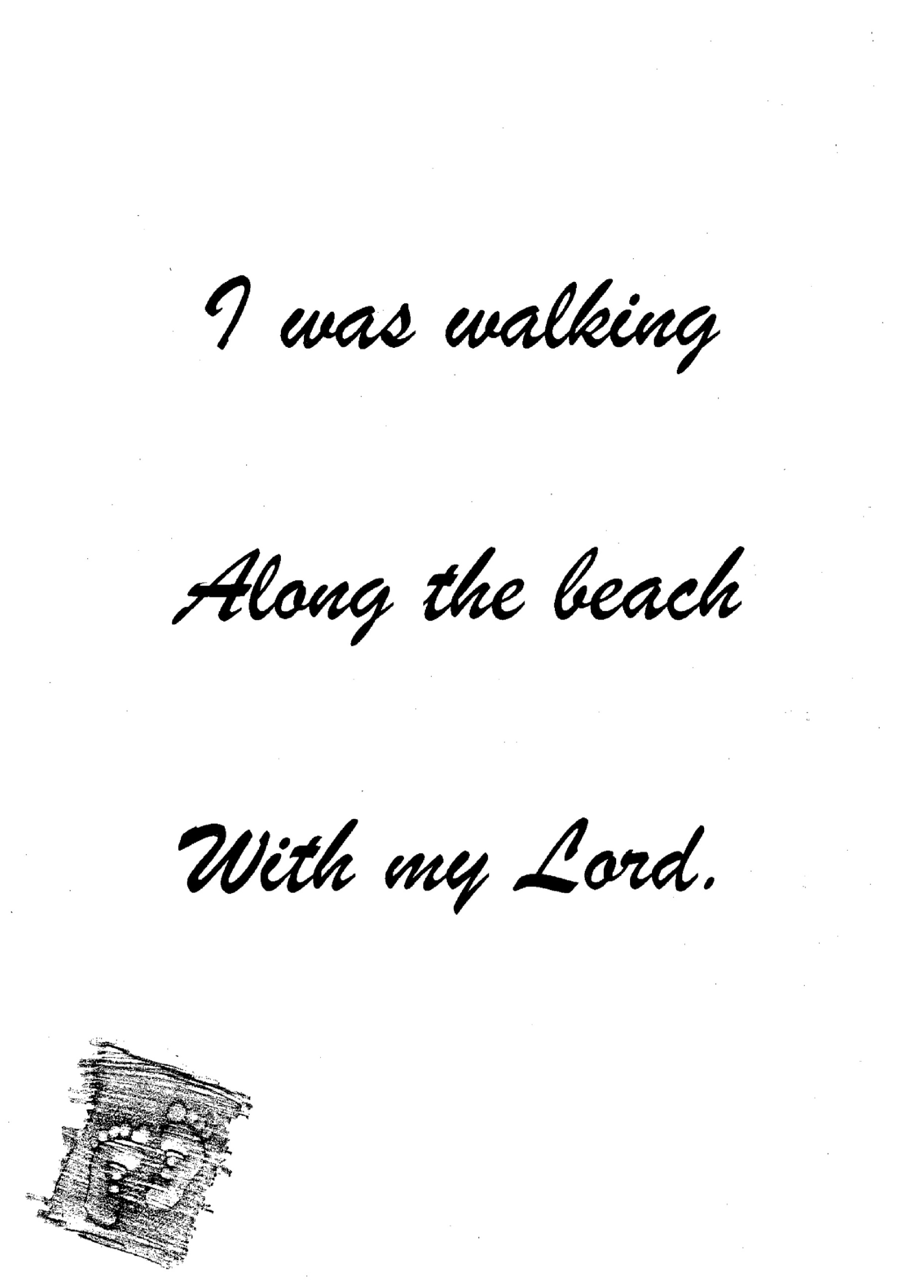

Reading

Leviticus 26 : 11, 12
11 I will set My tabernacle among you, and My soul shall not abhor you.
12 I will walk among you and be your God, and you shall be My people.

Genesis 6 : 9
9 This is the genealogy of Noah. Noah was a just man, perfect in his generations. Noah walked with God.

1 John 1 : 6
6 If we say that we have fellowship with Him, and walk in darkness, we lie and do not practice the truth.

John 17 : 20 -23
20 "I do not pray for these alone, but also for those who will believe in Me through their word;
21 that they all may be one, as You, Father, are in Me, and I in You; that they also may be one in Us, that the world may believe that You sent Me.
22 And the glory which You gave Me I have given them, that they may be one just as We are one:
23 I in them, and You in Me; that they may be made perfect in one, and that the world may know that You have sent Me, and have loved them as You have loved Me.

Meditation
Just as a consistent program of walking improves muscle tone and strengthens the heart. So our spiritual life will also reap benefits when we are consistent in walking with the Lord. A close walk with the Saviour will ensure a fellowship that will bring lasting joy, heavenly peace, and unending strength. God wants our walk with Him to be a joyful, shared togetherness. Such an intimate walk of faith with the Lord will assure us of His love. Our close fellowship with Him will help us cross the rough places on our journey home without the slightest care.

Singing : Trust and Obey

When we walk with the Lord,
In the light of His word,
What a glory He sheds on our way!
While we do His good will,
He abides with us still,
And with all who will trust and obey.
Trust and obey, for there's no other way
To be happy in Jesus, but to trust and obey.

Not a burden we bear,
Not a sorrow we share,
But our toil He doth richly repay.
Not a grief not a loss,
Not a frown not a cross,
But is blest if we trust and obey.
Trust and obey, for there's no other way
To be happy in Jesus, but to trust and obey.

Reading
John 14 : 1
1 "Let not your heart be troubled; you believe in God, believe also in Me.”

Isaiah 12 : 2
2 Behold, God is my salvation, I will trust and not be afraid; “For Yah, the Lord, is my strength and song; He also has become my salvation.”

Isaiah 40 : 31
31 But those who wait on the Lord Shall renew their strength; They shall mount up with wings like eagles, They shall run and not be weary, They shall walk and not faint.
Meditation
If we live with an attitude that looks back over our lives with the regrets, we are only robbing ourselves of God's mercy and assurance. God is the God of grace and hope. With God's perspective, we can trace His hand on our lives and see that He has transformed the bad things to good, just as He promised He would. As we face the uncertainties that today may bring, we have the assurance that God knows what we are facing. He is in touch with what is happening to us, and He is concerned. We can choose to live above regrets and live instead in God's peace and joy.
Singing : Ps 62 : 1, 4
In God alone my soul finds rest,
for in His faithfulness I trust;
from Him, alone, comes my salvation.
He is the rock that will not quake,
And none can this my strong-hold shake
Or move me from its firm foundation.

On God rests my deliverance,
and He my honour will advance;
He is my mighty rock, my shelter.
O people, trust in God alone;
to him make all your troubles known,
With his support you will not falter.

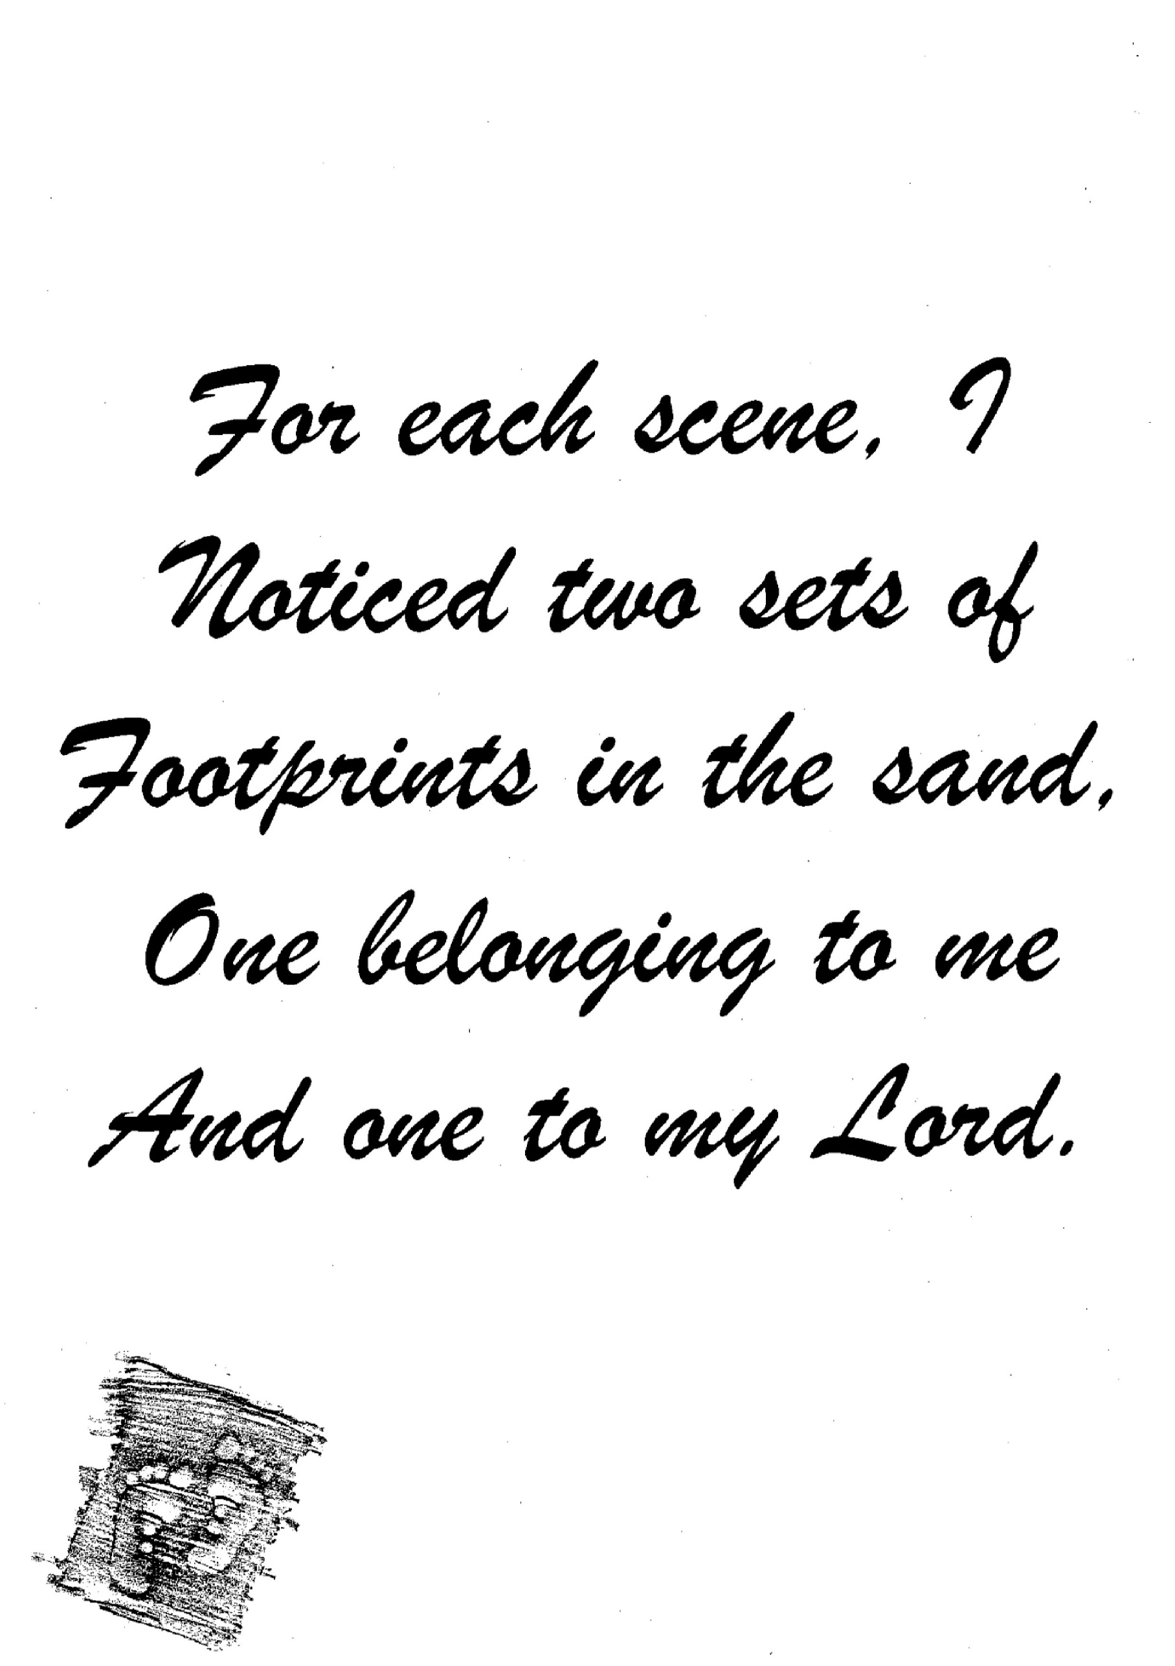
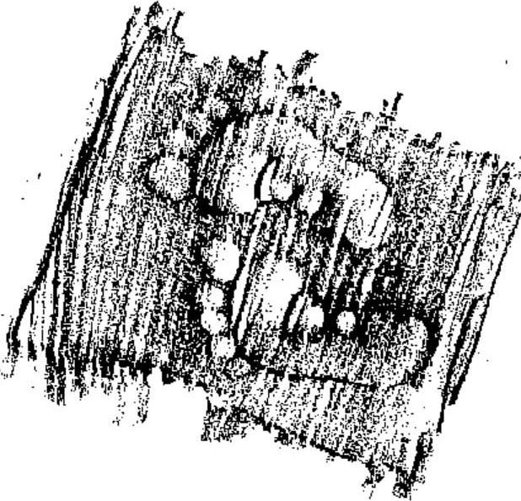
Reading

Psalm 138 : 7, 8
7 Though I walk in the midst of trouble, You will revive me; You will stretch out Your hand Against the wrath of my enemies, And Your right hand will save me.
8 The Lord will perfect that which concerns me; Your mercy, O Lord, endures forever; Do not forsake the works of Your hands.

Psalm 91 : 14 - 16
14 "Because he has set his love upon Me, therefore I will deliver him; I will set him on high, because he has known My name.
15 He shall call upon Me, and I will answer him; I will be with him in trouble; I will deliver him and honor him.
16 With long life I will satisfy him, And show him My salvation."

Psalm 139 : 7 - 12
7 Where can I go from Your Spirit? Or where can I flee from Your presence?
8 If I ascend into heaven, You are there; If I make my bed in hell, behold, You are there.
9 If I take the wings of the morning, And dwell in the uttermost parts of the sea,
10 Even there Your hand shall lead me, And Your right hand shall hold me.
11 If I say, "Surely the darkness shall fall on me," Even the night shall be light about me;
12 Indeed, the darkness shall not hide from You, But the night shines as the day; The darkness and the light are both alike to You.

Reading

Psalm 138 : 7, 8
7 Though I walk in the midst of trouble, You will revive me; You will stretch out Your hand Against the wrath of my enemies, And Your right hand will save me.
8 The Lord will perfect that which concerns me; Your mercy, O Lord, endures forever; Do not forsake the works of Your hands.

Psalm 91 : 14 - 16
14 "Because he has set his love upon Me, therefore I will deliver him; I will set him on high, because he has known My name.
15 He shall call upon Me, and I will answer him; I will be with him in trouble; I will deliver him and honor him.
16 With long life I will satisfy him, And show him My salvation."

Psalm 139 : 7 - 12
7 Where can I go from Your Spirit? Or where can I flee from Your presence?
8 If I ascend into heaven, You are there; If I make my bed in hell, behold, You are there.
9 If I take the wings of the morning, And dwell in the uttermost parts of the sea,
10 Even there Your hand shall lead me, And Your right hand shall hold me.
11 If I say, "Surely the darkness shall fall on me," Even the night shall be light about me;
12 Indeed, the darkness shall not hide from You, But the night shines as the day; The darkness and the light are both alike to You.

Meditation
The Lord enjoys walking with us as our companion on life's pathway. When we walk closely with Him, His presence encourages us and warms our hearts. He is our Strong provider, and He is in control of every aspect of our lives. He has promised never to leave us, He will provide for our every need. And He is stronger than any obstacle we may face, yet gentle enough to enfold us in His loving embrace. As God speaks His words of peace and blessing to our hearts, we can walk the path He has placed before us with assurance and joy.

Reading

2 Timothy 4 : 7 – 8
7 I have fought the good fight, I have finished the race, I have kept the faith.
8 Finally, there is laid up for me the crown of righteousness, which the Lord, the righteous Judge, will give to me on that Day, and not to me only but also to all who have loved His appearing.

Philippians 3 : 16
16 Nevertheless, to the degree that we have already attained, let us walk by the same rule, let us be of the same mind.

1 Peter 1 : 8, 9
8 whom having not seen you love. Though now you do not see Him, yet believing, you rejoice with joy inexpressible and full of glory,
9 receiving the end of your faith--the salvation of your souls.

Meditation
In Luke 9:62 Jesus reminds his listeners that there are consequences to looking back, to wishing things had been different. Whenever we look back over our lives, we need to do so with God's perspective rather than with an attitude of regret or sorrow only. We do not need to live a life of regrets. We can live with a forward-looking hope of glory. Though it may sometimes seem that things are out of control, we can always take comfort in God's enduring promises and constant presence. We can stand firm in the work of the Lord and live the life God offers us - a life free of regrets and full of joy.

Singing : Hymn 74 : 1 - 4

Our outer nature wastes away;
yet inwardly, from day to day,
we are in you renewed, 0 Lord.
Our suffering here is soon endured:
the harvest it for us prepares
by far outweighs our woes and cares.

A weight of glory, unsurpassed,
will then be ever ours at last,
for we find no security
in things that with our eyes we see;
for what is seen will fade away,
what is unseen will not decay.

We know that if our earthly tent
falls to the ground, all worn and rent,
our God as gift to us extends
a heav’nly house not made with hands,
a building steadfast and secure
that will eternally endure.

The Spirit we as pledge possess
of everlasting blessedness.
So let us of good courage be;
our God himself will make us free.
Let it be here and now our aim
to please Him and exalt His name.

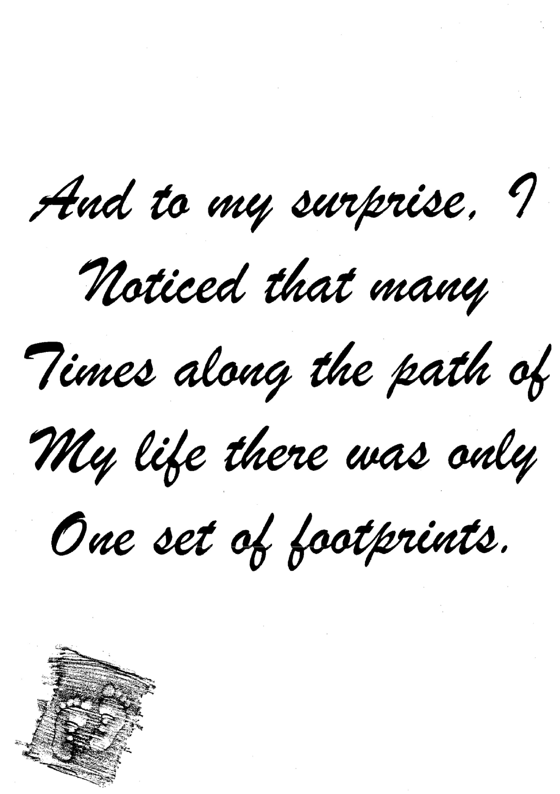
Reading

Isaiah 54:10
10 For the mountains shall depart and the hills be removed, but My kindness shall not depart from you, nor shall My covenant of peace be removed," says the Lord, who has mercy on you.

Isaiah 54 : 13, 14
13 All your children shall be taught by the Lord, and great shall be the peace of your children.
14 In righteousness you shall be established; You shall be far from oppression, for you shall not fear; and from terror, for it shall not come near you.

Isaiah 54 : 17
17 No weapon formed against you shall prosper, and every tongue which rises against you in judgment You shall condemn. This is the heritage of the servants of the Lord, And their righteousness is from Me," Says the Lord.

Meditation
The journey of life can sometimes be troubling. We often stumble and have difficulty following in God's footsteps. But we must never doubt God's presence with us. God will never let us down. He promises us His strength, His peace, His comfort, and His presence. When it seems that life is whirling out of control, we can take comfort in God's sovereignty and power. All we need to do is come to Him with our seeking hearts and know we can depend on Him. We can never break God's promises by leaning on them.

Singing : Abide with me
Abide with me; fast falls the eventide;
the darkness deepens; Lord, with me abide!
When other helpers fail; and comforts flee,
help of the helpless, O abide with me.

Swift to its close ebbs out life's little day;
earth’s joys grow dim, its glories pass away;
change and decay in all around I see –
O Thou who changes not, abide with me.

I need Thy presence every passing hour;
what but Thy grace can foil the tempter's power?
Who, like Thyself, my guide and stay can be?
Through cloud and sunshine, Lord, abide with me.

Reading
Matthew 11 : 28, 29
28 Come to Me, all you who labor and are heavy laden, and I will give you rest.
29 Take My yoke upon you and learn from Me, for I am gentle and lowly in heart, and you will find rest for your souls.

Isaiah 41 : 6
6 Everyone helped his neighbor, And said to his brother, "Be of good courage!"

Meditation
Sorrow may cause us to doubt God's plan. Yet God reminds us that He is aware of everything that is happening to us. No sorrow is too deep that God cannot feel it with us. Whatever the circumstances, He has everything under control. And He will work His will in every circumstance. Whenever we hit rock bottom, we can rest assured of God's love and care. He hears our heartfelt cries. His encouragement can breathe new possibilities into our impossible situations. And He will answer our prayers in ways that will fill us with joy and amazement.
Singing : As a Deer  1.As the deer pa-nts for the water, So my soul longs after You.  You alone are my heart’s desire And I long to worship You. | 2.I want You more than gold or silver Only You can satisfy.  You alone are the real joy-giver And the apple of my eye.

Refrain:
You alone are my strength, my shield
To You alone may my spirit yield.
You alone are my heart’s desire
And I long to worship You.
Refrain:
3.You're my Friend and You are my Brother Even though You are a King.
I love You more than any other,
So much more than anything

Refrain:

Poem : Does Jesus care? (Frank E. Graeff)
Does Jesus care when my heart is pained
too deeply for mirth and song;
as the burdens press, and the cares distress,
and the way grows weary and long?
Does Jesus care when my way is dark
with a nameless dread and fear?
As the daylight fades into deep night shades,
does He care enough to be near?
Does Jesus care when I've said goodbye
to the dearest on earth to me,
and my sad heart aches till it nearly breaks -
Is it anything to Him? Does He see?
0 yes He cares - I know He cares!
His heart is touched with my grief;
when the days are weary, the long nights dreary,
I know my Savior cares.
Reading

Nahum1 : 7
7 The Lord is good, A stronghold in the day of trouble; And He knows those who trust in Him.

1 Peter 5 : 7
7 casting all your care upon Him, for He cares for you.

Meditation
When the outlook is not good, we don't need to fret or worry. Fretting will only tie us in knots. Worry will only cast a big shadow over small problems – a shadow that should never cross our lives. We need to realize that God sees tomorrow more clearly than we see yesterday or today. The future is completely in His hands. We must trust that the Lord will take our faith, limited as it may be, and make it into something of lasting value. We need to get our arms around God's wisdom, remembering His faithfulness, and depend upon His grace. Whatever our questions, whatever our circumstances, God is still in control. He will give us the answer we seek.

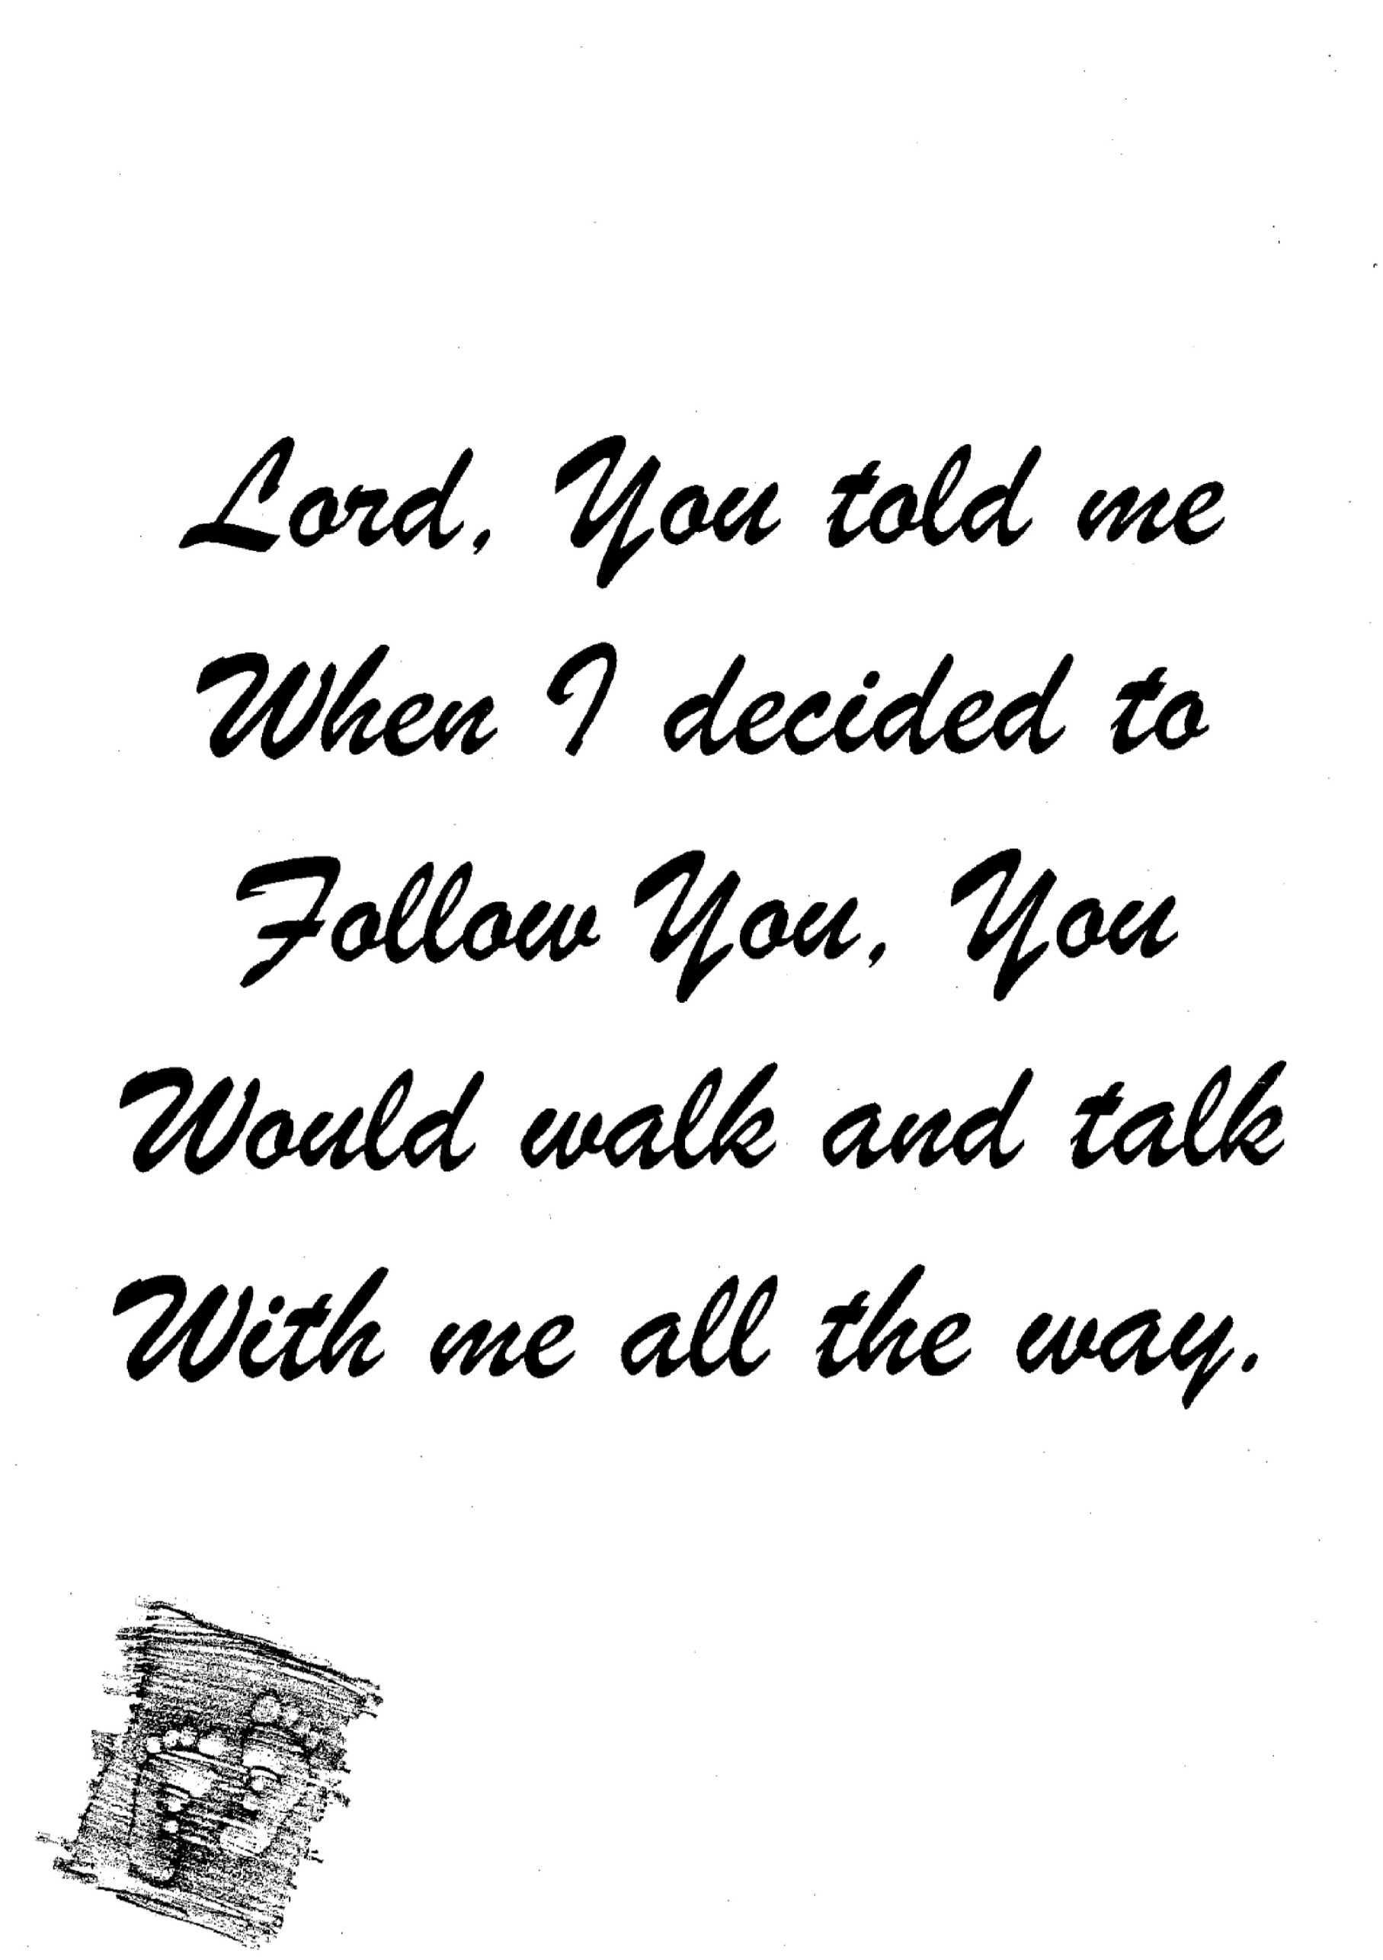

Reading

Hebrews 13 : 5 ,6
5 Let your conduct be without covetousness; be content with such things as you have. For He Himself has said, "I will never leave you nor forsake you."
6 So we may boldly say: "The Lord is my helper; I will not fear. What can man do to me?"

Isaiah 40 :28-31
28 Have you not known? Have you not heard? The everlasting God, the Lord, The Creator of the ends of the earth, Neither faints nor is weary. His understanding is unsearchable.
29 He gives power to the weak, And to those who have no might He increases strength.
30 Even the youths shall faint and be weary, And the young men shall utterly fall,
31 But those who wait on the Lord Shall renew their strength; They shall mount up with wings like eagles, They shall run and not be weary, They shall walk and not faint.

Meditation
Decisions, decisions, decisions. It sometimes seems that all we do is make decisions. Some decisions may be simple,' others may be complex. Yet sometimes the right choice may be obscure. We need someone to help to tell us what to do. When we face decisions
of all kinds, we should make sure to predicate our choices on our decisions to follow in His steps. Following the Lord means living your life the way He wants you to, yielding to His control in every situation. When we consistently walk with the Lord, we find clear direction, joyful hearts, and the assurance of God's presence in every circumstance.
Singing : The Lord's my Shepherd

1.The Lord's my Shepherd I'll not want;
He makes me down to lie
In pastures green; He leadeth me
The quiet waters by.

2.My soul He doth restore again,
And me to walk doth make
Within the paths of righteousness, E'en for His own Name's sake.
3.Yea thou I walk through death’s dark vale, Yet will I fear no ill,
For Thou art with me, and Thy rod
And staff me comfort still.

4.Goodness and mercy all my life
Shall surely follow me,
And in God's house forevermore
My dwelling place shall be
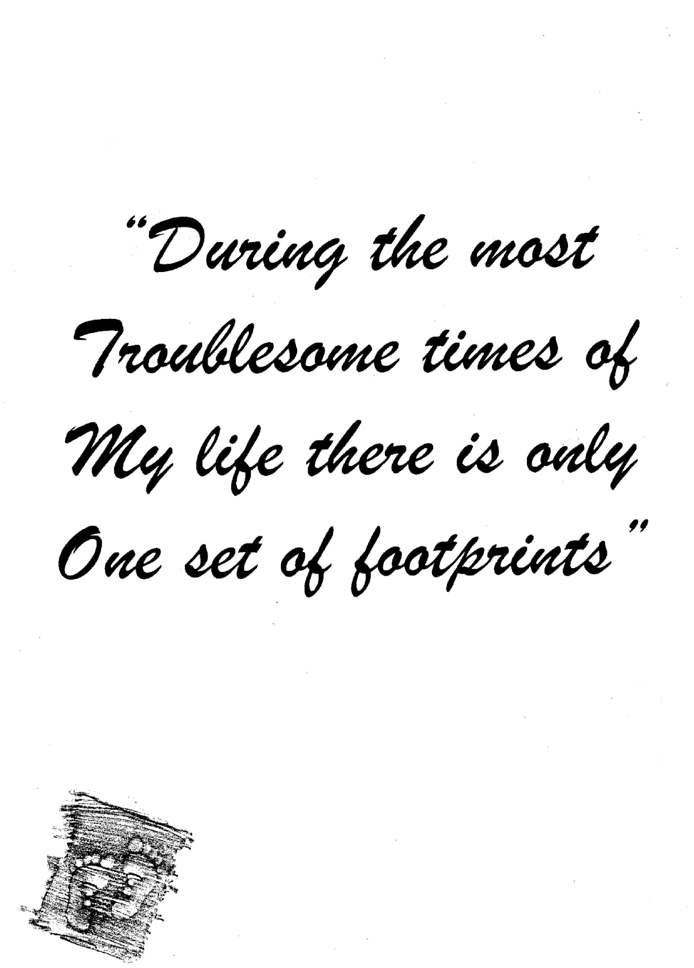
,
Reading

Psalm 55 : 22
22 Cast your burden on the Lord, And He shall sustain you; He shall never permit the righteous to be moved.

Isaiah 43 : 1 ,2
1 But now, thus says the Lord, who created you, O Jacob, And He who formed you, O Israel: "Fear not, for I have redeemed you; I have called you by your name; You are Mine.
2 When you pass through the waters, I will be with you; And through the rivers, they shall not overflow you. When you walk through the fire, you shall not be burned, Nor shall the flame scorch you.
Meditation
There are times in life when we feel bereft, abandoned, alone. When loneliness overtakes us we must remember that we are never alone. We can take comfort in God's promises
to be with us - in our joy and in our pain, in good times and in the bad times. God has promised that He will never forsake us. His steadfast love and faithfulness are promises we can cling to, promises that can bring us joy whenever we face the pangs of loneliness. Let us lean on these promises and receive God's peace. Let us walk in His footsteps and sense His strength. Let us stand in His presence and feel His love.

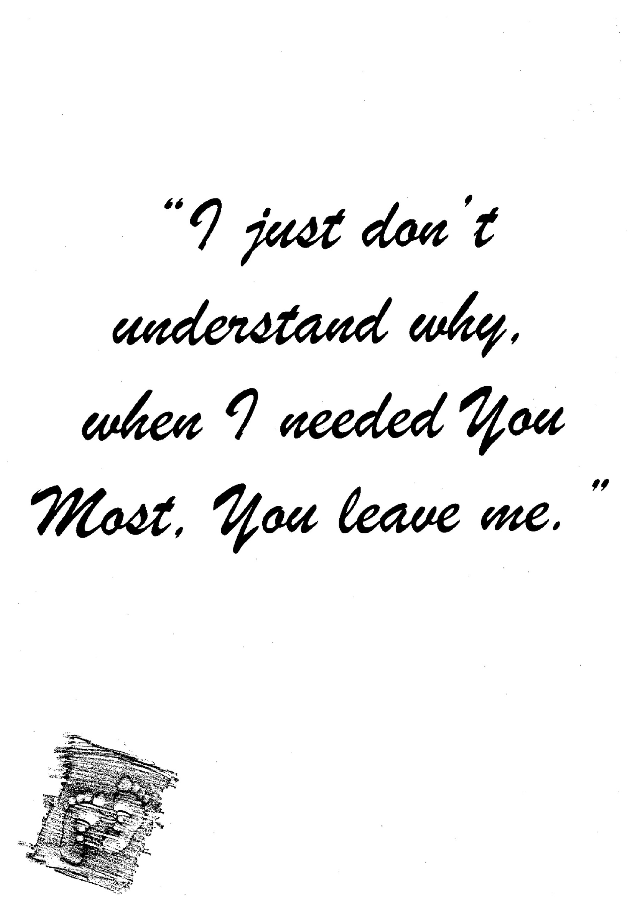
Poem: Never Alone (source unknown)
I've seen the lightning flashing
And heard the thunder roll,
I've felt sin's breakers dashing,
Which tried to conquer my soul;
I've heard the voice of my Savior,
He bid me still fight on -
He promised never to leave me,
Never to leave me alone.
No, never alone, no, never alone -
He promised never to leave me,
Never to leave me alone.

Reading:
Jeremiah 32 : 40, 41
40 And I will make an everlasting covenant with them, that I will not turn away from doing them good; but I will put My fear in their hearts so that they will not depart from Me.
41 Yes, I will rejoice over them to do them good, and I will assuredly plant them in this land, with all My heart and with all My soul.'

Lamentations 3 : 55 – 58
55 I called on Your name, O Lord, From the lowest pit.
56 You have heard my voice: "Do not hide Your ear From my sighing, from my cry for help."
57 You drew near on the day I called on You, And said, "Do not fear!"
58 O Lord, You have pleaded the case for my soul; You have redeemed my life.

Meditation:
When faced with bewildering circumstances, we may be tempted to ask, "Why." But a better question to ask is, "What do you have in mind now, LORD?" God always has a plan. God always has a purpose in every situation for those who follow in His footsteps. When we experience God's forgiveness, we are new creatures, God's presence is with us to help us, even when we don't realize it. There is hope. There is light in the darkness. Jesus Christ, God's Son, can strengthen our faith if we will patiently trust God's desire to make us more like Himself. We must put away all doubts, cast out all confusion. Then we will find a renewed faith as we follow in His footsteps.

Singing : Ps 86 : 2
You forgive us our transgressions
In your mercy and compassion;
You abound in love and grace.
In my woes I seek your face.
You, O LORD, will hear my pleading,
There’s no power yours exceeding.
You, O God, how great you are,
Reading
1 John 3 : 1, 2
1 Behold what manner of love the Father has bestowed on us, that we should be called children of God! Therefore the world does not know us, because it did not know Him.
2 Beloved, now we are children of God; and it has not yet been revealed what we shall be, but we know that when He is revealed, we shall be like Him, for we shall see Him as He is.

Romans 8 : 14 – 17
14 For as many as are led by the Spirit of God, these are sons of God.
15 For you did not receive the spirit of bondage again to fear, but you received the Spirit of adoption by whom we cry out, "Abba, Father."
16 The Spirit Himself bears witness with our spirit that we are children of God,
17 and if children, then heirs--heirs of God and joint heirs with Christ, if indeed we suffer with Him, that we may also be glorified together.

Isaiah 64 : 8
8 But now, O Lord, You are our Father; We are the clay, and You our potter; And all we are the work of Your hand.

Meditation
The Creator of the universe call us His children - what a blessing! What a privilege! What a responsibility! As children of God, we can trust that He will provide for us. We have the assurance that He created us and knows us by name. God also bestows us certain rights, privileges, and responsibilities as His heirs. Scripture reassures us that our loving heavenly Father will care for us just as a shepherd cares for his sheep. And as His children, our responsibility is to listen carefully to His voice and obey.
Singing : Hymn 45  1.Loving Shepherd of Thy sheep, all Thy lambs in safety keep;  nothing can Thy power withstand, none can pluck them from Thy hand.  2.May they praise Thee every day, gladly all Thy will obey;  like Thy blessed ones above, happy in Thy precious love. | 3.Loving Shepherd ever near,  teach Thy iambs Thy voice to hear; suffer not their steps to stray from the straight and narrow way.  4.Where Thou leadest may they go, walking in Thy steps below;  then, before Thy Father's throne, Saviour, claim them for Thine own.

Reading

Psalm 121
1 A Song of Ascents. I will lift up my eyes to the hills-- From whence comes my help?
2 My help comes from the Lord, Who made heaven and earth.
3 He will not allow your foot to be moved; He who keeps you will not slumber.
4 Behold, He who keeps Israel Shall neither slumber nor sleep.
5 The Lord is your keeper; The Lord is your shade at your right hand.
6 The sun shall not strike you by day, Nor the moon by night.
7 The Lord shall preserve you from all evil; He shall preserve your soul.
8 The Lord shall preserve your going out and your coming in From this time forth, and even forevermore.

Philippians 4 : 6, 7
6 Be anxious for nothing, but in everything by prayer and supplication, with thanksgiving, let your requests be made known to God;
7 and the peace of God, which surpasses all understanding, will guard your hearts and minds through Christ Jesus.

Meditation
Though we may face troubles and difficulties, sadness and pain, God is still in control, and He is always with us. When trouble rages; we must listen closely to God's voice. When the agonies of life begin to bear down upon us, God has not moved away from us. We may have moved away from Him. We must return to Him in faith and call on Him for His strength. He wants to bring us His divine comfort. Though things may seem hopeless, no trial is so great that God cannot deliver us, no pain is so great that He cannot bring us comfort, no circumstance is ever without God's presence. When God promises never to leave us, He means just that. He is in control.

Singing : What a Friend we have in Jesus  What a friend we have in Jesus,  All our sins and griefs to hear.  What a privilege to carry  Everything to God in prayer.  Oh what peace we often forfeit, Oh what needless pain we bear. All because we do not carry Everything to God in prayer.  Have we trials and temptations,  Is there troubles anywhere?  We should never be discouraged;  Take it to the Lord in prayer  Can we find a friend so faithful  Who will all our sorrows share?  Jesus knows our every weakness;  Take it to the Lord in prayer. | Are we weak and heavy laden, Cumbered with a load of care? Precious Savior still our refuge;  Take it to the Lord in Prayer.  Do thy friends despise, forsake Thee?  Take it to the Lord in prayer.  In His arms He'll take and shield thee;  thou wilt find a solace there.

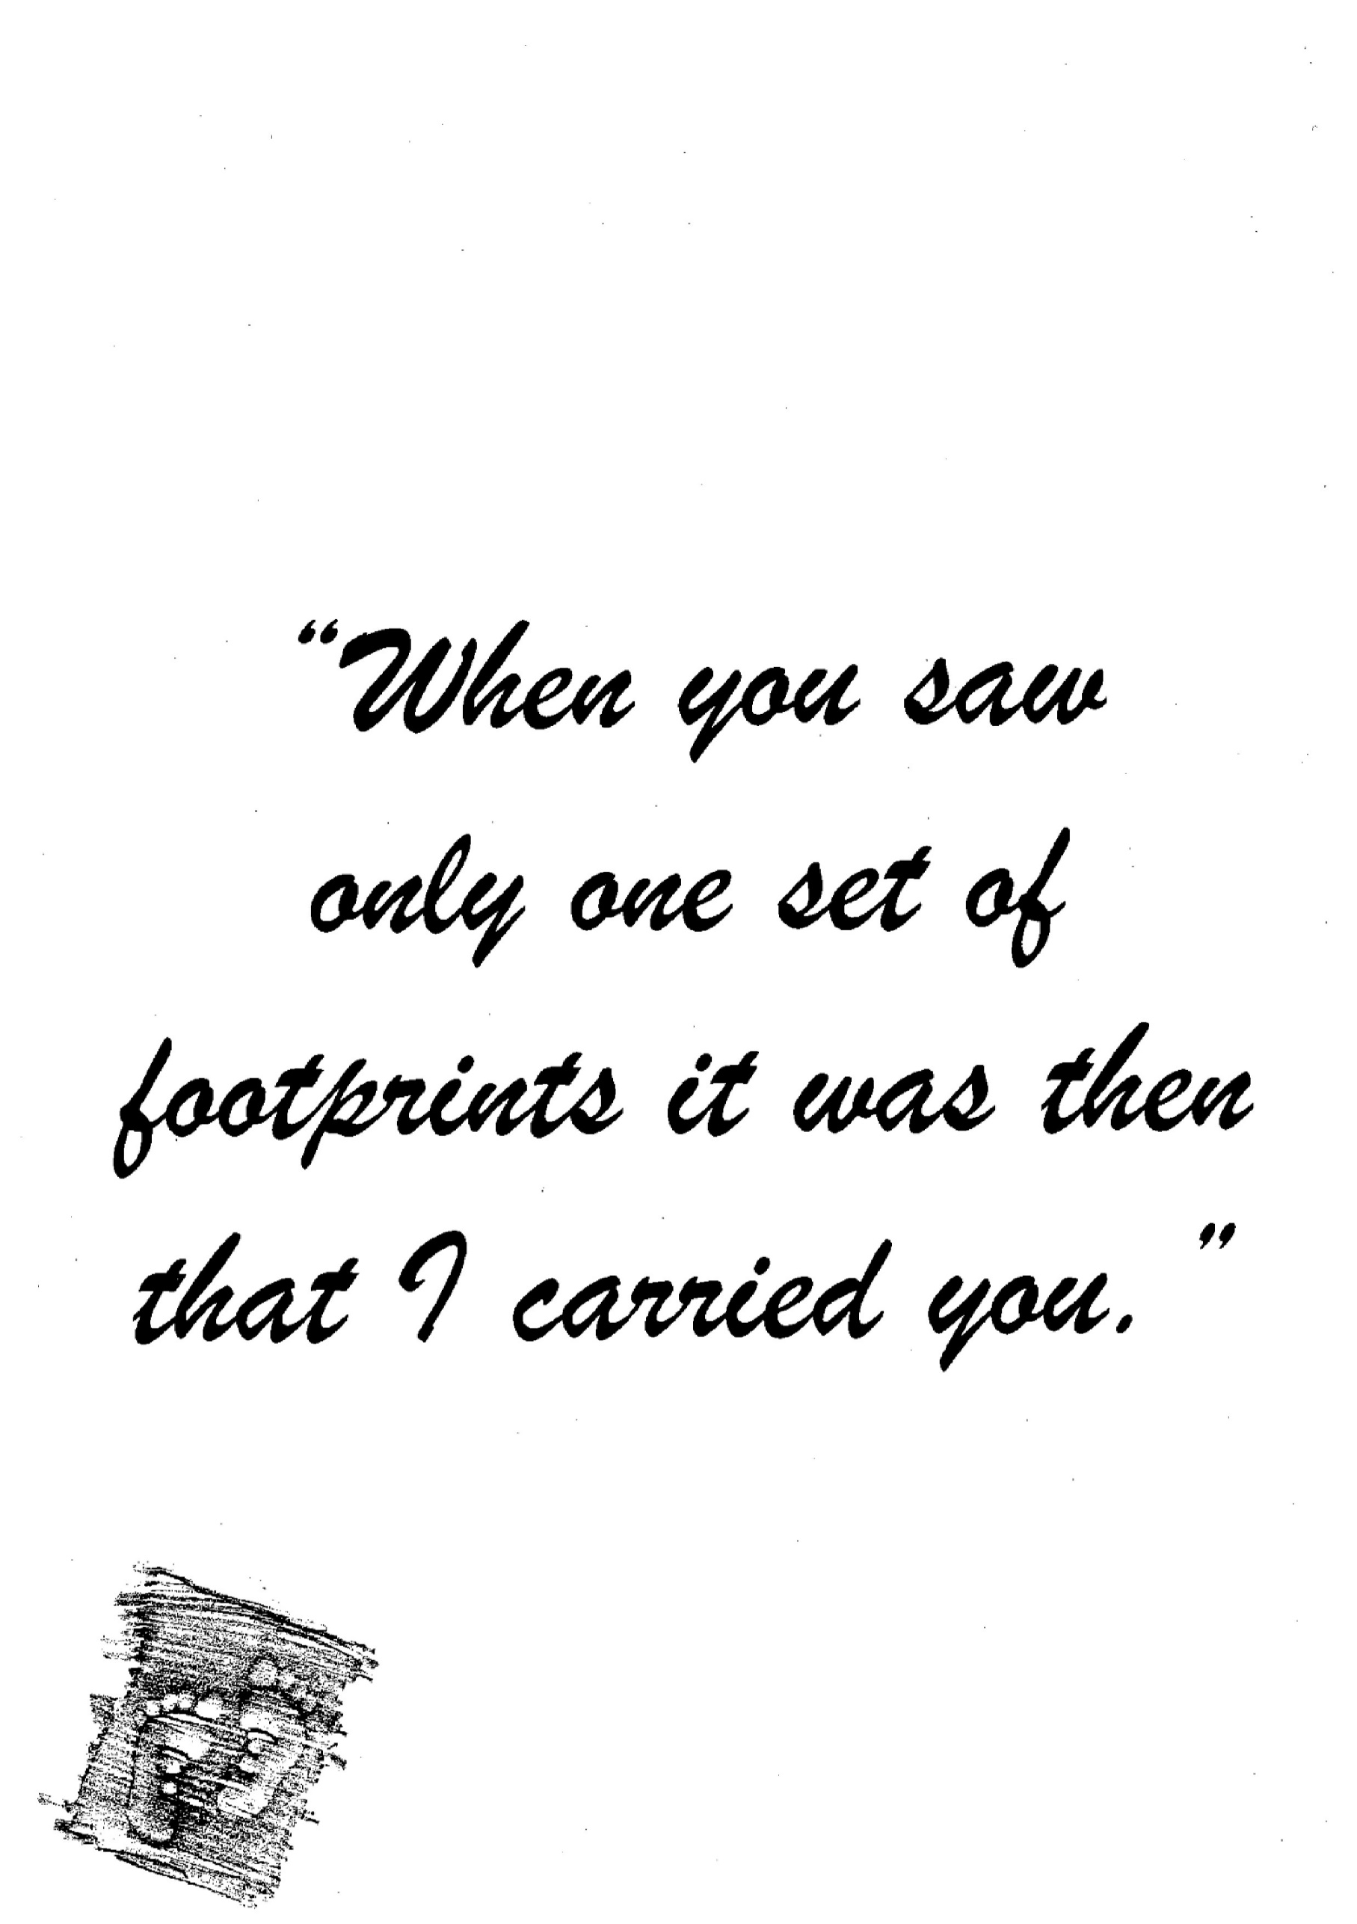
Reading

Isaiah 40 : 10, 11
10 Behold, the Lord God shall come with a strong hand, And His arm shall rule for Him; Behold, His reward is with Him, And His work before Him.
11 He will feed His flock like a shepherd; He will gather the lambs with His arm, And carry them in His bosom, And gently lead those who are with young.

Meditation
Though it seems as if the whole world has gone wrong around us, we are not alone. God is with us! He will prepare the way before us. He will carry us over the rough places. He will speak words of peace to our wounded hearts. All we need to do is trust in God's loving companionship as we walk closely with Him, and He will bring blessings into our lives. Our Heavenly Father is faithful and will never leave us or forsake us. As we come to Him daily, willing to be directed, He will guide us with His Word, shape our experiences, and stamp His signature on our lives as we follow in His footsteps.
Singing : Ps 103:6

Life is like grass, so quick to fade and perish,
Or like a flow’r that will but briefly flourish,
That sears and withers in the blowing wind;
Soon it is gone, not leaving any traces.
But God is ever merciful and gracious:
His love stands firm, abiding without end.
