Bedfordale : Christmas 1995

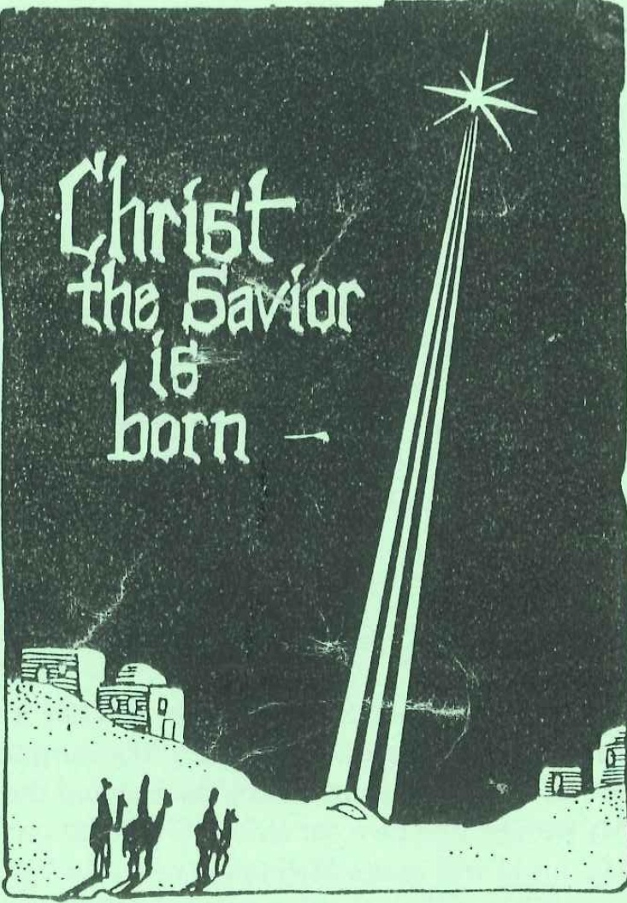

Bedfordale Christmas 1995

Singing Psalm 145 : 1
Prayer
Welcome
Reading Isaiah 48 : 17-19
17 Thus says the Lord, your Redeemer, The Holy One of Israel: "I am the Lord your God, Who teaches you to profit, Who leads you by the way you should go.
18 Oh, that you had heeded My commandments! Then your peace would have been like a river, And your righteousness like the waves of the sea.
19 Your descendants also would have been like the sand, And the offspring of your body like the grains of sand; His name would not have been cut off Nor destroyed from before Me."

Singing Psalm 89 : 9 and 12
Reading 2 Samuel 7 : 8, 9 and 16
8 Now therefore, thus shall you say to My servant David, 'Thus says the Lord of hosts: "I took you from the sheepfold, from following the sheep, to be ruler over My people, over Israel.
9 And I have been with you wherever you have gone, and have cut off all your enemies from before you, and have made you a great name, like the name of the great men who are on the earth.
16 And your house and your kingdom shall be established forever before you. Your throne shall be established forever.
Singing Psalm 132: 6 and 10
Reading Isaiah 51 : 3 – 6
3 For the Lord will comfort Zion, He will comfort all her waste places; He will make her wilderness like Eden, And her desert like the garden of the Lord; Joy and gladness will be found in it, Thanksgiving and the voice of melody.
4 "Listen to Me, My people; And give ear to Me, O My nation: For law will proceed from Me, And I will make My justice rest As a light of the peoples.
5 My righteousness is near, My salvation has gone forth, And My arms will judge the peoples; The coastlands will wait upon Me, And on My arm they will trust.
6 Lift up your eyes to the heavens, And look on the earth beneath. For the heavens will vanish away like smoke, The earth will grow old like a garment, And those who dwell in it will die in like manner; But My salvation will be forever, And My righteousness will not be abolished.

Singing Psalm 102 : 6 and 7

Reading Micah 5 : 2
2 "But you, Bethlehem Ephrathah, Though you are little among the thousands of Judah, Yet out of you shall come forth to Me The One to be Ruler in Israel, Whose goings forth are from of old, From everlasting."
Singing Hymn 16 : I, 4 and 5 –O Come, O Come, Emmanuel

Reading Isaiah 40 : 1 – 5
1 "Comfort, yes, comfort My people!" Says your God.
2 "Speak comfort to Jerusalem, and cry out to her, That her warfare is ended, That her iniquity is pardoned; For she has received from the Lord's hand Double for all her sins."
3 The voice of one crying in the wilderness: "Prepare the way of the Lord; Make straight in the desert A highway for our God.
4 Every valley shall be exalted And every mountain and hill brought low; The crooked places shall be made straight And the rough places smooth;
5 The glory of the Lord shall be revealed, And all flesh shall see it together; For the mouth of the Lord has spoken."

Singing Hymn 11 - Comfort, Comfort Now My People

Reading Isaiah 9 : 2 and 6
2 The people who walked in darkness Have seen a great light; Those who dwelt in the land of the shadow of death, Upon them a light has shined.
6 For unto us a Child is born, Unto us a Son is given; And the government will be upon His shoulder. And His name will be called Wonderful, Counselor, Mighty God, Everlasting Father, Prince of Peace.
Singing Hymn 19 : 1, 3 and 4 – The People Who in Darkness Walked
Music Excerpt from "Messiah" : "For unto us a Child is born..."
Reading John 1 : 1 and 14a
1 In the beginning was the Word, and the Word was with God, and the Word was God. 14a And the Word became flesh and dwelt among us.

Luke 1 : 26 - 28, 31
26 Now in the sixth month the angel Gabriel was sent by God to a city of Galilee named Nazareth,
27 to a virgin betrothed to a man whose name was Joseph, of the house of David. The virgin's name was Mary.
28 And having come in, the angel said to her, "Rejoice, highly favored one, the Lord is with you; blessed are you among women!"
31 And behold, you will conceive in your womb and bring forth a Son, and shall call His name Jesus.

Reading Matthew 1 : 21

21 And she will bring forth a Son, and you shall call His name Jesus, for He will save His people from their sins.
Singing Silent Night
Silent Night, Holy Night,
David's son, Lord of light,
Born for millions salvation to bring,
In the manger lies Jesus the King,
Christ the Saviour is born,
Christ the Saviour is born.
Silent Night, Holy Night,
Peace poured out, Grace supplied,
to a world which is covered with sin,
Send Your Spirit, Lord, dwelling within,
Christ the Saviour is born,
Christ the Saviour is born.
Reading "The Virgin Birth" by Prof. NTH. Gootjes.
http://www.clarionmagazine.ca/archives/1994/585-694_v43YE.pdf
Singing Hymn 20 : 1 and 2
Hymn 17 : 1 and 3
Reading Luke 2 : 13 and 14
13 And suddenly there was with the angel a multitude of the heavenly host praising God and saying:
14 "Glory to God in the highest, And on earth peace, goodwill toward men!"
Singing Hymn 21 : 1, 5 & 6 – While Shepherds Watched Their Flocks by Night
Singing Angels from the Realms of Glory (melody : Glory be to God the Father)
Angels from the Realms of Glory,
wing your flight o’er all the earth;
Ye who sang creation's story,
Now proclaim Messiah's birth.
Come and worship,
Come and worship,
Worship Christ the Newborn King.
Reading Luke 2 : 20
20 Then the shepherds returned, glorifying and praising God for all the things that they had heard and seen, as it was told them.

Singing Shepherds in the fields abiding

Shepherds in the fields abiding,
Tell us when the seraph bright.
Greeted you with wondrous tiding,
What you saw and heard that night.
Gloria in Excelsis Deo,
Gloria in Excelsis Deo.

Reading Hebrews 1 : 1 – 4
1 God, who at various times and in various ways spoke in time past to the fathers by the prophets,
2 has in these last days spoken to us by His Son, whom He has appointed heir of all things, through whom also He made the worlds;
3 who being the brightness of His glory and the express image of His person, and upholding all things by the word of His power, when He had by Himself purged our sins, sat down at the right hand of the Majesty on high,
4 having become so much better than the angels, as He has by inheritance obtained a more excellent name than they. .
Singing Psalm 2 : 3

Reading John 3 : 16
16 For God so loved the world that He gave His only begotten Son, that whoever believes in Him should not perish but have everlasting life.
Isaiah 53 : 4 and 5
4 Surely He has borne our griefs And carried our sorrows; Yet we esteemed Him stricken, Smitten by God, and afflicted.
5 But He was wounded for our transgressions, He was bruised for our iniquities; The chastisement for our peace was upon Him, And by His stripes we are healed.
Singing Hymn 23 : 1, 3 and 6

Reading Revelation 1 : 8a and 18a
Jesus declares of Himself :
8a I am the Alpha and the Omega…..
18a I am He who lives, and was dead, and behold, I am alive forevermore.
Reading And the church of all ages confesses of Him that: On the third day He arose
from the dead; He ascended into heaven, and sits at the right hand of God the Father almighty; from there He will come to judge the living and the dead.

Singing Hymn 3 : 4

Reading 2 Peter 3 : 10 - 13

10 But the day of the Lord will come as a thief in the night, in which the heavens will pass away with a great noise, and the elements will melt with fervent heat; both the earth and the works that are in it will be burned up.
11 Therefore, since all these things will be dissolved, what manner of persons ought you to be in holy conduct and godliness,
12 looking for and hastening the coming of the day of God, because of which the heavens will be dissolved, being on fire, and the elements will melt with fervent heat?
13 Nevertheless we, according to His promise, look for new heavens and a new earth in which righteousness dwells.

Revelation 21 : 1 and 2, 22 and 23
1 Now I saw a new heaven and a new earth, for the first heaven and the first earth had passed away. Also there was no more sea.
2 Then I, John, saw the holy city, New Jerusalem, coming down out of heaven from God, prepared as a bride adorned for her husband.
22 But I saw no temple in it, for the Lord God Almighty and the Lamb are its temple.
23 The city had no need of the sun or of the moon to shine in it, for the glory of God illuminated it. The Lamb is its light.

Singing Hymn. 73 : 1 and 2
Interval
Singing Hymn 68 : 1, 6 and 8
Quiz
Closing
Singing Hymn 67 : 1, 2 and 6

