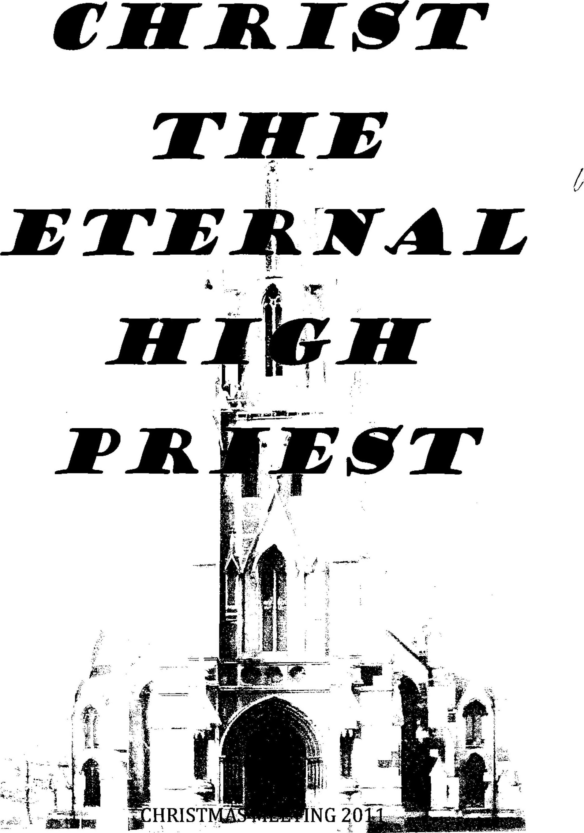

CHRISTMAS MEETING 2011

WOM ENS STUDY CLUBS

WEST ALBANY

End of Year Meeting - Celebrating the Birth of Our Saviour

OPENING
SING: HYMN 12 : 14
O come and with His people now rejoice;
shout forth your praises, all ye nations!
To thank the LORD lift up your voice
and sing your songs of jubilation.
The LORD is good His mercy great:
his servants He will vindicate,
wreak vengeance on His adversaries.
His chosen people He has shown
the cov'nant love that never varies
and for their land will He atone.
SCRIPTURE READING: PSALM 138
1 A Psalm of David. I will praise You with my whole heart; Before the gods I will sing praises to You.
2 I will worship toward Your holy temple, And praise Your name For Your lovingkindness and Your truth; For You have magnified Your word above all Your name.
3 In the day when I cried out, You answered me, And made me bold with strength in my soul.
4 All the kings of the earth shall praise You, O Lord, When they hear the words of Your mouth.
5 Yes, they shall sing of the ways of the Lord, For great is the glory of the Lord.
6 Though the Lord is on high, Yet He regards the lowly; But the proud He knows from afar.
7 Though I walk in the midst of trouble, You will revive me; You will stretch out Your hand Against the wrath of my enemies, And Your right hand will save me.
8 The Lord will perfect that which concerns me; Your mercy, O Lord, endures forever; Do not forsake the works of Your hands.
THE BEGINNING
READ: HEBREWS 1:10-12
10 "You, Lord, in the beginning laid the foundation of the earth, And the heavens are the work of Your hands.
11 They will perish, but You remain; And they will all grow old like a garment;
12 Like a cloak You will fold them up, And they will be changed. But You are the same, And Your years will not fail."

RECITATION: IN THE BEGINNING:
In the beginning, the very beginning
The first beginning was God
God spoke His word and created the world.
No, not by dust, or elements or any little part
God spoke one Word, one MIGHTY Word
He spoke the light and called it day
He spoke in the night in a wondrous way
He spoke the land, He spoke the sea
The sun and moon and stars spoke He
He spoke, really there is no end to what appeared at His command.

SING: PSALM 8:1 & 4
O LORD, our Lord, yours be all adoration.
How glorious is your name in all creation!
You have displayed your majesty on high;
Your glory reaches far above the sky.

You little lower than divine have made him
and so with glorious honour have arrayed him.
All things you gave to him as his domain,
That over your creation he might reign.

FALL INTO SIN
RECITATION:
In this new world, this brand new world,
this brilliant world stood man.
He knew His God, he knew His voice,
he knew His great command.
He looked away from what was good
and reached the forbidden fruit.
He listened to God's enemy
and he despised God's company.
He took the step ahead and fell
forgetting all he knew so well
the love of God, the grace of God
the burning jealousy of God.
He fell.

READ: LAMENTATIONS 5 : 15 – 17
15 The joy of our heart has ceased; Our dance has turned into mourning.
16 The crown has fallen from our head. Woe to us, for we have sinned!
17 Because of this our heart is faint; Because of these things our eyes grow dim;
SING: PSALM 141 : 6 and 7
As new-ploughed earth with rocks is cluttered
As barren fields are strewn with stones,
So, as it were, our very bones
Before the gaping grave lie scattered.

LORD, my eyes I fix now directly
On you, my helper in the strife.
Save me from danger, guard my life;
In your unfailing love, protect me.

READ: GENESIS 3: 15
15 And I will put enmity between you and the woman, And between your seed and her Seed;
He shall bruise your head, And you shall bruise His heel."

RECITATION:
Our hope began when God broke our alliance with the devil.
God did not allow us to fall under the everlasting spell of the devil.
Immediately He put enmity: between him and us. That was God's grace. He loved us.
When we fell and sinned, He did not permit us to embrace evil but placed enmity between the children of Eve and the brood of the serpent.

The unholy alliance between mankind and the devil was broken the day it started. Instead of an alliance, God made it a battle: 'I will put enmity between you (serpent) and-the woman".

SING: I WILL PUT ENMITY (round)
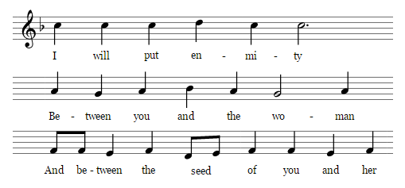
Sing 3 times. 1st unison, 2nd and 3rd round as advised
I n t e r v a l

THE HIGH PRIEST WE NEED

READ: LEVITICUS 16 : 29 – 34
29 "This shall be a statute forever for you: In the seventh month, on the tenth day of the month, you shall afflict your souls, and do no work at all, whether a native of your own country or a stranger who dwells among you.
30 For on that day the priest shall make atonement for you, to cleanse you, that you may be clean from all your sins before the Lord.
31 It is a sabbath of solemn rest for you, and you shall afflict your souls. It is a statute forever.
32 And the priest, who is anointed and consecrated to minister as priest in his father's place, shall make atonement, and put on the linen clothes, the holy garments;
33 then he shall make atonement for the Holy Sanctuary, and he shall make atonement for the tabernacle of meeting and for the altar, and he shall make atonement for the priests and for all the people of the assembly.
34 This shall be an everlasting statute for you, to make atonement for the children of Israel, for all their sins, once a year."
SING: PSALM 105 : 3
He is the LORD our God unfailing,
His judgments everywhere prevailing.
He will remember and uphold
His cov’nant made in days of old.
The steadfast words of His command
A thousand generations stand.

READ: HEBREWS 8 : 8 -10
"Behold, the days are coming, says the Lord, when I will make a new covenant with the house of Israel and with the house of Judah--
9 not according to the covenant that I made with their fathers in the day when I took them by the hand to lead them out of the land of Egypt; because they did not continue in My covenant, and I disregarded them, says the Lord.
10 For this is the covenant that I will make with the house of Israel after those days, says the Lord: I will put My laws in their mind and write them on their hearts; and I will be their God, and they shall be My people.

RECITATION:
According to Jeremiah's prophecy, the new covenant would bring about a lasting communion with God and function with much greater strength. For the promises were "better" because God's Law would be written on the hearts of the people and no longer on tablets of stone.
The people would obey them, and they would no longer be dependent on prophets and priests to know the LORD. All this would rest upon the firm foundation of the forgiveness of sins. Now in fulfillment of Jeremiah's prophecy it must be concluded that the old covenant is no longer valid, and has been replaced by one which is new.
God has fulfilled the promise of this new covenant. He appointed for Himself a High Priest who would make the ultimate sacrifice for sin.

SING: PSALM 51: 6 & 7
LORD, you do not in sacrifice delight;
or else I would with off’rings try to please you.
How could I ever with my gifts appease you?
Burnt off’rings find no favour in your sight.
One gift alone is pleasing in God’s eyes:
the contrite heart of one who has repented.
A broken spirit you will not despise
when humbly as a sacrifice presented.

In your good pleasure, bless Jerusalem;
cause her to thrive, and shield her with your power.
Build Zion’s walls, O God uphold her towers
safeguard her citadels and strengthen them.
Then you in sacrifices will delight,
in gifts of those whom you in Zion shelter;
Burnt off'rings will be pleasing in your sight.
Then will young bulls offered on your altar.

RECITATION:

What kind of mediator and deliverer must we seek?
One who is a true and righteous man,
and yet more powerful than all creatures,
that is, one who is at the same time true God.

But who is that Mediator who at the same time is true God
and a true and righteous man?
Our Lord Jesus Christ, who became to us wisdom from God,
righteousness and sanctification and redemption.

READ: HEBREWS 7 : 26 – 28
26 For such a High Priest was fitting for us, who is holy, harmless, undefiled, separate from sinners, and has become higher than the heavens;
27 who does not need daily, as those high priests, to offer up sacrifices, first for His own sins and then for the people's, for this He did once for all when He offered up Himself.
28 For the law appoints as high priests men who have weakness, but the word of the oath, which came after the law, appoints the Son who has been perfected forever.

RECITATION:
Christ is the High Priest whom we need. He complies with all the requirements set down, and He offered the "once for all" sacrifice, the sacrifice of Himself The old law appointed men who were weak and sinful, who, consequently, had to make offering first of all for their own sins. But the Word of God in His oath appointed someone who has been made perfect forever, One whom God addresses as His Son.

CHRIST IS BORN
RECITATION:
During the Christmas season, we remember with great joy the birth of Christ, the Perfect High Priest.
SING: TO GOD BE THE GLORY: 1 and 3
To God be the glory! Great things He has done!
So loved He the world that He gave us His Son,
Who yielded His life an atonement for sin
and opened the life-gate that all may go in.

Refrain: Praise the Lord, praise the Lord!
Let the earth hear His voice!
Praise the Lord, praise the Lord!
Let the people rejoice!
O come to the Father through Jesus the Son
and give Him the glory- great things He has done!

Great things He has taught us, great things He has done
and great our rejoicing through Jesus the Son.
But purer and higher and greater will be
our wonder, our transport, when Jesus we see!
Refrain:

READ: ISAIAH 9 : 6, 7
6 For unto us a Child is born, Unto us a Son is given; And the government will be upon His shoulder. And His name will be called Wonderful, Counselor, Mighty God, Everlasting Father, Prince of Peace.
7 Of the increase of His government and peace There will be no end, Upon the throne of David and over His kingdom, To order it and establish it with judgment and justice From that time forward, even forever. The zeal of the Lord of hosts will perform this.

SING: O COME, ALL YE FAITHFUL: 1 and 2
O come, all ye faithful, joyful and triumphant,
O come ye, O come ye to Bethlehem;
Come and behold Him born the King of angels:

Refrain: O come let us adore Him, O come let us adore Him,
O come let us adore Him, Christ the Lord.

Sing, choirs of angels, sing in exultation,
O sing all ye bright hosts of heaven above;
Glory to God, all glory in the highest:
Refrain:

READ: LUKE 2 : 1 – 7
1 And it came to pass in those days that a decree went out from Caesar Augustus that all the world should be registered.
2 This census first took place while Quirinius was governing Syria.
3 So all went to be registered, everyone to his own city.
4 Joseph also went up from Galilee, out of the city of Nazareth, into Judea, to the city of David, which is called Bethlehem, because he was of the house and lineage of David,
5 to be registered with Mary, his betrothed wife, who was with child.
6 So it was, that while they were there, the days were completed for her to be delivered.
7 And she brought forth her firstborn Son, and wrapped Him in swaddling cloths, and laid Him in a manger, because there was no room for them in the inn.

READ: LUKE 2 : 8 – 14
10 Then the angel said to them, "Do not be afraid, for behold, I bring you good tidings of great joy which will be to all people.
11 For there is born to you this day in the city of David a Savior, who is Christ the Lord.
12 And this will be the sign to you: You will find a Babe wrapped in swaddling cloths, lying in a manger."
13 And suddenly there was with the angel a multitude of the heavenly host praising God and saying:
14 "Glory to God in the highest, And on earth peace, goodwill toward men!" 8 Now there were in the same country shepherds living out in the fields, keeping watch over their flock by night.
9 And behold, an angel of the Lord stood before them, and the glory of the Lord shone around them, and they were greatly afraid.

SING: HARK! THE HERALD ANGELS SING:
Hark! the herald angels sing,
"Glory to the new-born King”;
Peace on earth, and mercy mild:
God and sinners reconciled.
Joyful, all ye nations rise,
Join the triumph of the skies;
with the angelic hosts proclaim:
"Christ is born in Bethlehem!"
Hark! the herald angels sing:
“Glory to the new-born King."

RECITATION:
Listening to the words of the angels and understanding what they said precisely, we discover a few things. In the first place we realise that "peace" in the word of God is not exactly what the world generally understands by it. In general, it is understood to mean that no war is going on but that each one lets the others live their own lives the way they want it. The Lord gives a peace which means first of all an undisturbed relationship with Him. No longer is anything standing between Him and us. The fruit of this is further that the light of His favour shines upon all our days, our whole life, so that our life can develop harmoniously. The peace of which the angels speak is given to the people of God's good pleasure only, to those whom it seemed good to God in His infinite mercy to endow with Christ's treasures: the ones whose lives are characterised by undeserved mercies and forfeited gifts. This peace is not general. The coming of Christ did not obliterate the difference between the two groups into which the human race is divided. It maintained and accentuated this difference. Sharing in God's good pleasure we have peace with Him through Christ our Saviour.

SING: JOYFUL SOUNDS THE SONG OF ANGELS
Joyful sounds the song of angels
through the skies of Ephratah.
Glory, glory in the highest,
Praise the Lord, Hallelujah.

Refrain: Lo, from heaven are angels winging,
Of God's pleasure they are singing,
Peace on earth the Lord is bringing,
Peace through Jesus. He is King.

Jesus, Thou on earth revealed
As a lowly Child, unknown,
Through the coming we'll be pealed,
Thou wilt make the cross Thy throne.
Refrain:

Help us Lord to seek salvation
At the manger, near the cross.
Make us free from tribulation
And present us with Thy grace.
Refrain:

Interval

RECITATION:
From Christmas we move to Good Friday; the day Christ as Pascal lamb offered himself up for us.

READ: HEBREWS 10 : 4 - 7, 9b – 10
4 For it is not possible that the blood of bulls and goats could take away sins.
5 Therefore, when He came into the world, He said: "Sacrifice and offering You did not desire, But a body You have prepared for Me.
6 In burnt offerings and sacrifices for sin You had no pleasure.
7 Then I said, 'Behold, I have come-- In the volume of the book it is written of Me-- To do Your will, O God.'”
9 b He takes away the first that He may establish the second. 10 By that will we have been sanctified through the offering of the body of Jesus Christ once for all.

SING : HYMN 25:1 & 3
Who has believed our message from on high
that God's own Son, who laid His glories by,
came down from heaven to suffer and to die
for our transgression?
Who saw revealed in Him God's power and favour -
the mighty arm of Him who sent our Saviour,
that we, His people, might be free forever
from sin and shame?

Our suff’rings and infirmities he bore;
our sorrows he was willing to endure,
while we thought he was being punished for
His own wrongdoing.
But He was pierced because of our transgression,
bruised for our sin; His punishments and passion
procured our peace: His scourging and oppression
healed us again.

CONCLUSION
RECITATION:
However, Christ did not remain in the grave, but conquering death, He arose and now sits at our Father's right hand.

READ: HEBREWS 10 : 19 – 25
19 Therefore, brethren, having boldness to enter the Holiest by the blood of Jesus,
20 by a new and living way which He consecrated for us, through the veil, that is, His flesh,
21 and having a High Priest over the house of God,
22 let us draw near with a true heart in full assurance of faith, having our hearts sprinkled from an evil conscience and our bodies washed with pure water.
23 Let us hold fast the confession of our hope without wavering, for He who promised is faithful.
24 And let us consider one another in order to stir up love and good works,
25 not forsaking the assembling of ourselves together, as is the manner of some, but exhorting one another, and so much the more as you see the Day approaching.

SING: HYMN 42 : 1, 2 and 6
Where high the heav’nly temple stands,
the house of God not made with hands,
Christ has the greatest honour gained,
yet very God and man remained.

Our great High Priest, our Saviour, Lord,
gives to His saints on earth support,
since He through all the heav'ns has passed.
To this confession we hold fast.

Let us then boldly seek God's face,
there to find mercy, help and grace,
our great High Priest will intercede,
come to our aid in time of need.

READ: HEBREWS 13:20, 21
20 Now may the God of peace who brought up our Lord Jesus from the dead, that great Shepherd of the sheep, through the blood of the everlasting covenant,
21 make you complete in every good work to do His will, working in you what is well pleasing in His sight, through Jesus Christ, to whom be glory forever and ever. Amen.

PRAYER:

SING: PSALM 67:1 and 3
May God be merciful and bless us
and cause His face on us to shine;
May He to us be ever gracious,
Illumine us with light divine.
May He to all nations
show His revelation
and His way unfold.
Great is God our Saviour;
May all see His favour
And His power behold.

Let all the earth, O God, our Saviour
Your love and faithfulness extol.
The land has yielded through Your favour
Its harvest rich and bountiful.
God is good and gracious
He will richly bless us –
He, our God and King.
Let all peoples fear Him,
all the earth revere Him
of His glory sing.

